AN IN-DEPTH ASSESSMENT OF LAND GOVERNANCE IN NAMIBIA

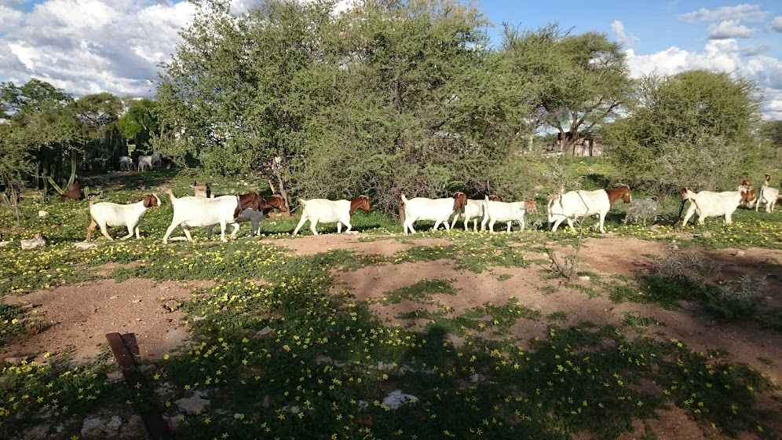

Prepared by

Sam M. Mwando
Tigisty Maswahu
Innocent Phiri Panga-Panga
Michael Mutale
Mwala Lubinda
Dr. Christopher C. Nshimbi

24.07.19

WINDHOEK, NAMIBIA

Contents
Contents ii
Executive Summary iv
List of Acronyms and Abbreviations v
List of Tables and Figures vi
Acknowledgements vii
1 Section A: Introduction and Background 1
1.1 Study Objective 1
1.2 Importance of Good Land Governance in Agriculture Investment 1
1.2.1 Economy and Geography of Namibia 3
1.2.2 Governance System 4
1.3 Land Tenure and Institutional Framework in Namibia 4
1.4 The Theory of Change of Land Governance in Namibia 8
1.4.1 Guiding Principles, Process and Outcomes: 8
1.4.2 Perception of Land Tenure Insecurity: 8
1.4.3 Clear Land Rights in Land Administration and Management: 10
1.4.4 Equitable Distribution and Access to Land for Economic Empowerment: 10
1.4.5 Gender Equality and Empowerment for All Women in Land Administration: 11
1.4.6 Multi-Sectoral Approach in Land Governance Implementation: 12
2 Section B: Methodology for the Adapted Land Governance Assessment Framework (LGAF) 14
2.1 Implementation of the Adapted Land Governance Assessment Framework 15
2.2 Assessment of Land Governance in Namibia 16
2.2.1 Clarity of institutional and legal mandates 16
2.2.2 Transparency of Land Use Rezoning in Communal Areas 17
2.2.3 Land Tenure Recognition 17
2.2.4 Public Provision of Land Information 19
2.2.5 Respect for and Enforcement of Land Rights 20
2.2.6 Agriculture Land Valuation 21
2.2.7 Justification for Expropriation of Agricultural Land 22
2.2.8 Transparency of Expropriation Procedures 24
2.2.9 Resettlement Programme in Maps 25
2.2.10 National Resettlement Programme (NRP) 28
2.2.11 Cost-Effectiveness, Accessibility, and Sustainability 28
2.2.12 Dispute Resolution and Conflict Management 29
2.2.13 Large-Scale Land Acquisitions 31
2.2.14 Absentee Landlords and Underutilization of Land 33
3 Section C: Consolidated substantive findings of the assessment 34
3.1 Policy Recommendation Matrix 42
4 Conclusion 46
5 Bibliography 47
6 List of Legal Instruments and Policies 51
7 Appendix 52

Executive Summary

This report presents an assessment of the land governance in Namibia. The overall objective of the report was to carry out an in-depth country analysis of the status of land policy and land governance in the context of the Malabo Declaration to support the development of the National Agriculture Investment Plan (NAIP) for Namibia. The methods employed for this assessment combined rapid adapted Land Governance Assessment Framework (LGAF), interviews, collection and analysis of government documents, review of literature and secondary data. The report covers five primary areas. First, it highlights the need for clarity of institutional and legal mandates in land governance, considering the pluralistic tenure regime in Namibia. Second, it explains how land tenure recognition is integral to any meaningful investments in land for both subsistence and commercial farmers. Third, it notes why consistent agriculture valuation practices are necessary for mitigating against risk by financial institutions and revenue collection by the state. Fourth, it highlights lacunas in the expropriation procedures, and how these challenges impede on the goals of land reforms in Namibia. Fifth, it emphasises the need for alternative dispute resolution mechanisms as a tool to avoid legal costs for state and non-state actors alike. The report also acknowledges the areas where Namibia is doing well such as the existence of a legal and institutional framework, budget allocation to land related programmes, availability of finance to farmers in communal areas and the existence of a functioning National Spatial Data Infrastructure (NSDI).
The assessment concludes with policy recommendations regarding the institutional and legal arrangements, rethinking the National Resettlement Programme (NRP), the need for research-based policy formulation, young and emerging farmer support and transparency and awareness on the importance of good land governance in supporting agriculture investments in Namibia.
The general policy implications from this study point to the following measures:
• Lack of evidence-based policy formulation
• Fragmented land reform programmes
• Lack of coherent policies
• Weak co-ordination

List of Acronyms and Abbreviations

AU African Union
AALS Affirmative Action Loan Scheme
CAADP Comprehensive African Agriculture Development Programme
CLB Communal Land Board
GDP Gross Domestic Product
GRN Government of the Republic of Namibia
HPP Harambee Prosperity Plan
JICA Japan International Cooperation Agency
LGAF Land Governance Assessment Framework
MLR Ministry of Land Reform
MAWF Ministry of Agriculture, Water and Forestry
MD Malabo Declaration
IRLUP Integrated Regional Land Use Planning
NAIP National Agriculture Investment Plan
NDP National Development Plan
NRP National Resettlement Programme
NSDI National Spatial Data Infrastructure
NSA National Statistics Agency
SDG Sustainable Development Goal

List of Tables and Figures
Figure 1: Land Tenure Map of Namibia 2
Figure 2: Chronology of the enactment of Land Laws in Namibia 7
Figure 3: Theory of change 12
Figure 4: Total number of resettled beneficiaries issued with lease agreements per region 25
Figure 5: Farms acquired for resettlement programme in communal and commercial areas (2016/17) 25
Figure 6: Farms acquired through national resettlement programme 26
Figure 7: Land reform beneficiaries in Namibia 26
Figure 8: Lease agreements signed in communal and commercial areas (2016/17) 27
Figure 9: Report brainstorm session 55
Figure 10: Final aide memoire Namibia country convening meeting 55
Figure 11: Malabo declaration 55

Table 1: Synopsis of legal and institutional arrangements 5
Table 2: Clarity of institutional and legal mandates 16
Table 3: Recognition of land rights 17
Table 4: Completeness of registry information 19
Table 5: Enforcement of rights 20
Table 6: Transparency of valuation 21
Table 7: Transparency of procedures 22
Table 8: Cost effectiveness, accessibility and sustainability 28
Table 9: Assignment of responsibility for dispute resolution 29
Table 10: Large-scale acquisition of land rights 31
Table 11: Foreign ownership of agricultural land by nationality 32
Table 12: A sample of the logical framework 41
Table 13: Policy Matrix 43
Table 14: Consolidated LGAF scores 53

Acknowledgements
The research consortium would like to acknowledge Deutsche Gesellschaft für Internationale Zusammenarbeit (GIZ) GmbH through the Strengthening Capacities for Land Governance in Africa (SLGA) for its financial and technical support. The consortium is also grateful to the participants of the Malabo Domestication Country Convening meeting and the brainstorming session (Potential, Purpose and Scope of a Strategy for the Agri-Food Sector in Namibia) held in Windhoek, Namibia on 11th to 14th February and 16th to 17th April 2019 respectively.

We would also like to thank numerous institutions and individuals for their contribution in giving their insights on land governance in Namibia. Lastly, we would also like to thank the Department of Land and Property Sciences at Namibia University of Science and Technology for according us the time to undertake this assignment.

Section A: Introduction and Background

Study Objective

The study sought to conduct an in-depth country assessment on land policy/governance in Namibia. Fundamental to the study was to establish the extent to which the current land policy/governance system supports agriculture investment and productivity in Namibia. The guiding principle for this assessment is the Malabo Declaration, which among other commitments, aims to end hunger in Africa by 2025; enhancing investment finance in agriculture and resilience of livelihoods and production systems to climate variability and other related risks.

Importance of Good Land Governance in Agriculture Investment

Good land governance is cited as a critical ingredient for achieving continental Agenda 2063 and Namibia’s Vision 2030, particularly goals related to quality of life and well-being (AU Goal 1), agriculture (AU Goal 5), environment (AU Goal 7), peace and security (AU Goal 13), and gender equality (AU Goal 17). Similarly, good land governance also underpins the achievement of the Sustainable Development Goals (SDGs), especially goals related to: eliminating poverty (SDG1); ending hunger and promoting sustainable agriculture (SDG2); gender equality and women empowerment (SDG5); inclusive economic growth (SDG8); productive employment (SDG11); human settlements (SDG 11), and peaceful and inclusive societies (SDG16).

Efficient land governance is a critical ingredient to achieving the commitments under the Malabo Declaration, particularly commitment related to: enhancing investment finance in agriculture (Commitment 2); ending hunger in Africa by 2025 (Commitment 3); halving poverty by the year 2025, through inclusive agricultural growth and transformation (Commitment 4); and enhancing resilience of livelihoods and production systems to climate variability and other related risks (Commitment 6). Furthermore, good land governance ensure that investors, either the biggest industrialist or a small-scale subsistence farmer, can invest in their land without hesitation or fear of expropriation, encroachment or land grabbing. Broadly, Namibia is divided into three land tenure types comprising of freehold (42%), communal (35%) and state (23%) land of the 824,290 Km² land mass.

Namibia is an upper-middle-income country with an approximated population of 2.4 million people. It is southern Africa’s most sparsely populated country. It has a total land mass of approximately 824,290 square kilometres. The country is characterised by scarce productive land and fragile soils, coupled with limited water resources and erratic rainfall. The country has broadly a dichotomous land tenure system comprising of freehold and communal land (see figure 1 below). Approximately 70 % of the population depends on subsistence agro-pastoralism, mostly in communal areas. The Vision 2030, the Fifth National Development Plan and the Harambee Prosperity Plan (HPP), all of which recognise the importance of alleviating poverty and contribute to achieving Sustainable Development Goals 2 and 17, guide development in Namibia.

Figure 1: Land Tenure Map of Namibia
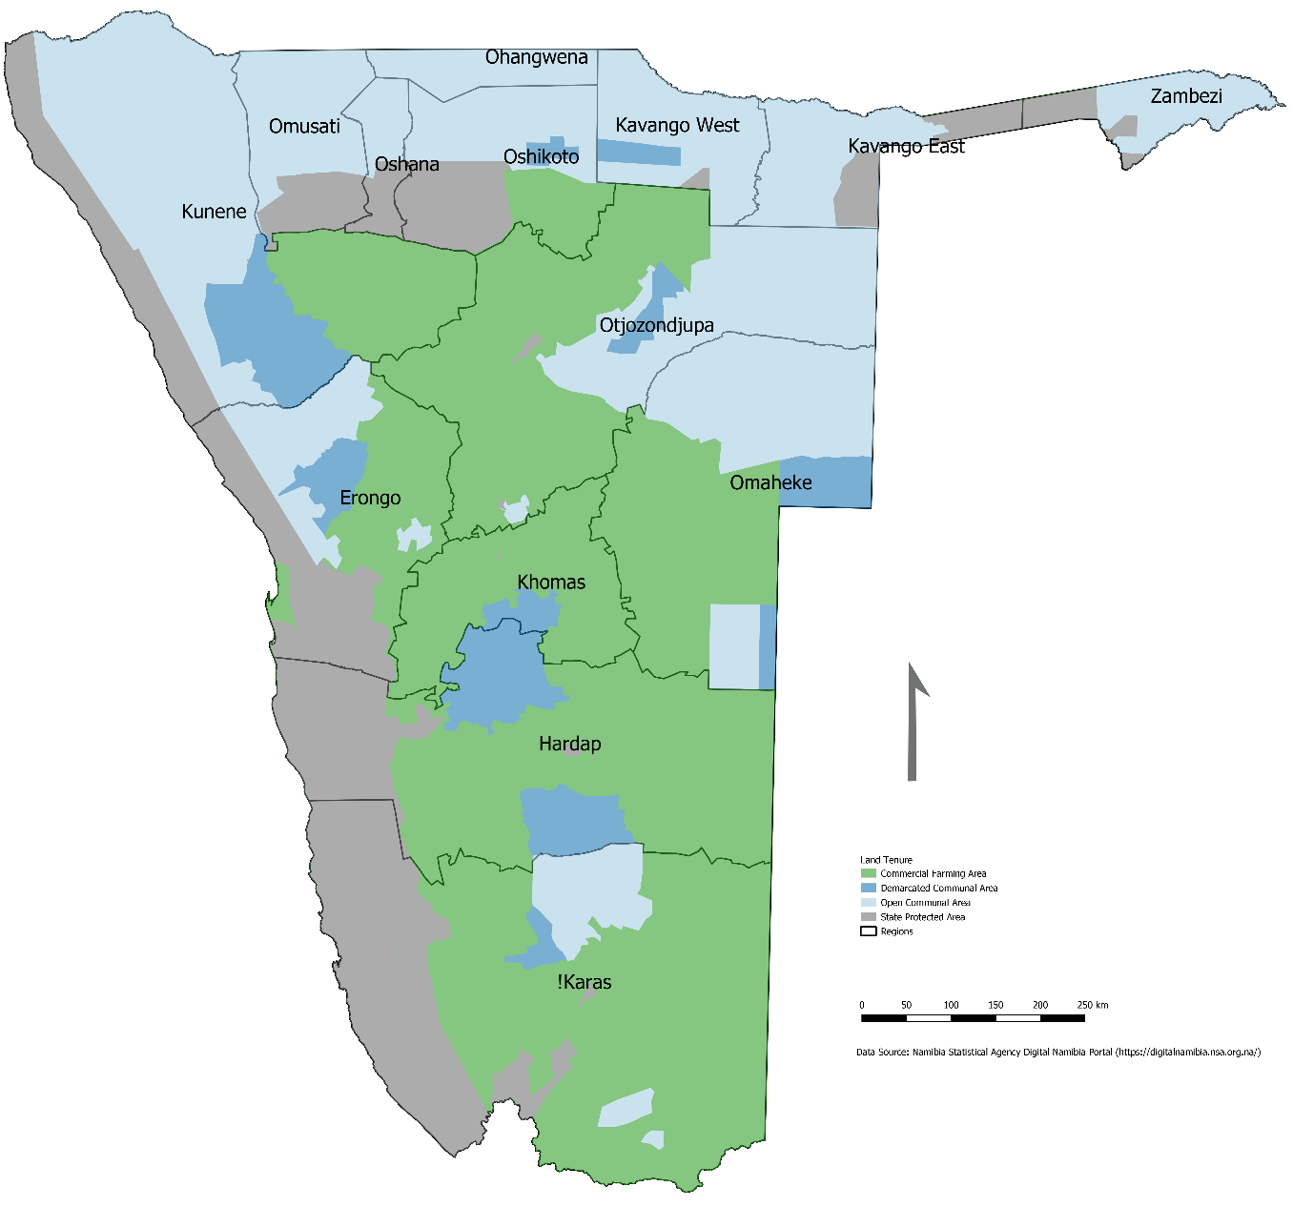

Economy and Geography of Namibia

The real economy is estimated to have contracted by 1 per cent in 2018. This was largely attributed to a sharp contraction in the construction sector and the sluggish recovery in the mining and quarrying sector – i.e., both contribute significantly to the country’s Gross Domestic Product (GDP). The continuation of the fiscal consolidation process has caused domestic consumption to stall. Fiscal consolidation effected mainly through reductions in capital expenditures, has affected most sectors of the economy, especially construction and tertiary sector activities. Nonetheless, the Bank of Namibia expects the economy to perform better in 2019 spurred by recoveries in the mining and agricultural sectors.

The Namibian population was estimated at 2.2 million in 2011 (51.6 per cent female and 48.4 per cent male), an increase of 15.4% compared to the 2001 population. Population projections indicate further growth of 2.28% by end of 2019 (Countrymetres, 2019). More people still live in the rural areas despite evidence of urbanization. Whereas the urban population grew by 49.7% between 2001 and 2011, the rural population declined by 1.4 per cent over the same period. The population is young (36.5 percent under the age of 15) and females live longer than the males.

Preliminary data from the Namibia Household Income and Expenditure Survey 2015/16 indicates that the country is experiencing a decline, with the upper poverty line headcount ratio falling from 28.7% in 2009/10 to 18.0% in 2015/16. The Gini Coefficient for Namibia is estimated to have fallen to 0.57 in 2015/16 from 0.60 in 2009/10. Although this downward trend is encouraging, income inequality in Namibia is still among the highest in the world.

The employment-to-population ratio for Namibia is 45.8% nationwide, though gender and locational disparities persist. Agriculture is the sector with the largest number of workers, accounting for 20.1% of employment. In 2016, informal employment was estimated to account for 67.5% of total employment. Unemployment remains a considerable social issue in Namibia, particularly among young people. Youth unemployment (15 to 34 years) stands at 43.4%, against an overall unemployment rate of 34.0%. Both unemployment rates have deteriorated from their 2014 levels, with youth unemployment growing by 4.5% while overall unemployment increased by 6.1%.

Namibia’s environmental challenges are multifaceted. They include water scarcity, desertification, land degradation, bush encroachment, deforestation and climate change. Among these challenges, climate change poses the greatest risk. Namibia is extremely vulnerable to climate change impacts primarily due to its exposure and low adaptive capacity. For Namibia, global warming and drying will be greater than the global average. Even the Paris Climate Agreement goal of limiting global warning to ideally 1.50C will have severe local impacts. Water supply, agriculture, health, tourism and biodiversity are all negatively impacted. Therefore, there is an urgent need to accelerate Namibia’s climate change adaptation response.

Governance System

Namibia is a parliamentary democracy with a multiparty system employed since independence in 1990. The president is the head of state and government. The government of Namibia has three branches: the executive, legislature and judiciary. The constitution of Namibia is the supreme law of the country.

The Namibian government is partly centralised and partly regional. In the executive branch, the central government consists of ministries, offices and agencies, whereas the regional government consists of Regional councils or municipality, town councils and constituencies. The legislation is centralised in the lower house called the National Assembly, and regional in the upper house known as the National Council. The judiciary is centralised in the Supreme Court, whereas High Courts and lower courts are distributed all over the country.

Land Tenure and Institutional Framework in Namibia

As stated earlier, there are broadly two main categories of tenure in Namibia namely, freehold and communal land, as summarised in Table 1 below:

Table 1: Synopsis of legal and institutional arrangements

Synopsis of legal and institutional arrangements in Namibia
Current Land Tenure System (Post Independence) | Article 100 of the Namibian Constitution states that land belongs to the state, if not otherwise, lawfully owned. The following are the recognised types of land tenure in Namibia:  State land is land used for nature conservation, game parks, agricultural research farms and military bases. It also includes land owned by local authorities in urban areas for development and sale (to private developers).  Private land includes urban land which is privately owned within proclaimed boundaries and rural commercial farmland or freehold agricultural land, i.e. private ownership of commercial farmlands.  Communal land includes all land used by indigenous communities, owned by the state but held in trust for them. All rural land in the communal areas is held and managed according to customary tenure systems.
Current Status of Land Policies | The 1998 National Land Policy advocates that all persons are equal before the law and no one should be discriminated against on the grounds of sex, colour, ethnic origin, religion, creed, social or economic status. The policy aims to promote sustainable economic development, address inequitable land distribution and increased population pressure, reduce poverty and promote tenure security and offer multiple forms of land rights.  The revised National Resettlement Policy of 2018 aims to ensure that Namibia’s land resource is equitably allocated, efficiently managed, administered and sustainably utilized for the benefit of all Namibians.  The Namibia Agriculture Policy of 2015’s vision is to attain a conducive environment for sustainable agricultural production, marketing and agro-industry development in Namibia. The policy promotes, regulates and protects the sustainable development of the agriculture sector through stakeholder participation for the purpose of improving the socio-economic situation of the Namibian people. The policy also aims to accelerate the agriculture sector’s contribution to National Gross Domestic Product and to promote the development of the national agriculture sector across the value chain.
Rural Land Administration | In the Communal Land Reform Act (Act 5 of 2002), communal land is described in section 15 as: land which includes areas described as communal land in Schedule 1 of the Act, any areas declared to be communal land under section 16(1)(a), and any land incorporated into a communal land area under section 16(1)(b). Local authority areas within the boundaries of a communal land area do not form part of communal lands.  The Communal Land Reform Act, Section 17, states that all communal land is vested in the State, which must keep the land in trust for the benefit of the traditional communities living in those areas. Since communal land belongs to the State, the State has put up systems in place to make sure that communal lands are administered and managed in the interest of the people living in those areas. The Act incorporates the offices of the Chief or the Traditional Authority and the Communal Land Boards which work together to ensure better communal land administration.  The Act also stipulates that communal land cannot be sold as freehold land to any person, which means that communal land cannot be sold like commercial farmland.
Legal and Institutional Framework in Land Governance in Namibia | The Local Authorities Act (Act 23 of 1992) provides for local authority administration. Regional Councils have general responsibility to allocate resources. Local authorities are responsible for the development of land for housing and for the sale of residential plots, which are transferable with freehold title.  Twelve regional Communal Land Boards (CLBs) have been established under the Communal Land Reform Act of 2002. Different ministries and all traditional authorities recognized under the Traditional Authorities Act are represented on these boards.  According to Section 24 of the Local Authorities Act of 1992, while the traditional authority may allocate customary land rights, the relevant board must ratify the allocation before it is legally valid.  The Ministry of Land Reform (MLR), which was established in 1990, is the main actor in land planning and administration in Namibia. It’s functions are spread under the different directorates as explained below:  The Directorate of Land Reform administers the Agricultural (Commercial) Land Reform Act (Act 6 of 1995), the Communal Land Reform Act (Act 5 of 2002) and implements the National Land Policy.  The Directorate of Deeds Registry administers the Deeds Registries Act (Act 47 of 1937) and regulations and Registration of Deeds in Rehoboth Act (Act 93 of 1976). The directorate is responsible for the registration of immovable properties and real rights granted by financial institutions in the country.  The Directorate of Survey and Mapping provides services in support of land planning, surveying, mapping and administration. It also provides professional services and advice to the government, parastatals, private companies and the general public on the matter relating to survey and mapping and derives its mandate from the Land Survey Act (Act 33 of 1993).  The Directorate of Valuation and Estate Management carries out valuations of agricultural land for land tax administration purposes, as provided for in the Agricultural (Commercial) Land Reform Act (Act 6 of 1995), together with the Land Valuation and Taxation Regulations of 2007.  The Directorate of Regional Programme and Implementation facilitates implementation of the Communal Land Reform Act (Act 5 of 2002) and the Agricultural (Commercial) Land Reform Act (Act 6 of 1995) and other land reform policies and legislations. See figure 2 for the overview of major legal instruments passed since 1991.

Figure 2: Chronology of the enactment of Land Laws in Namibia
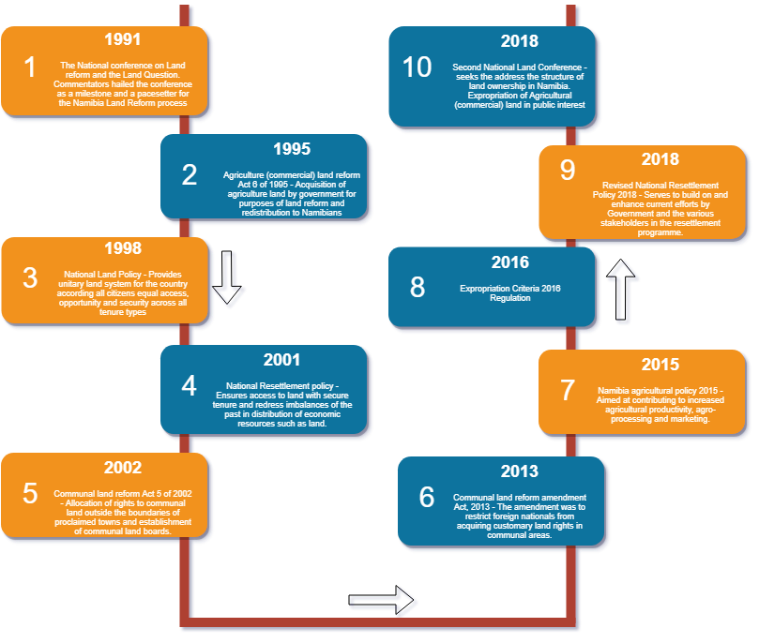

The Theory of Change of Land Governance in Namibia

The theory of change is defined as ‘the set of assumptions about the manner in which the programme (in this case Namibia’s land governance) relates to the benefits it is expected to produce (agriculture investment and productivity) (Lisher, 2018; Project Oracle, 2014). It is a plausible and sensible model of how the land governance system in Namibia is supposed to function. The model is operational/strategic in nature and highlights the intentional and sequential progression of the stakeholders’ actions to a hierarchy of outcomes. It therefore plots a chain of expected changes arising from planned activities.

Guiding Principles, Process and Outcomes:

The guiding principles of the Malabo Declaration are a basis for commitment, solidarity and collective responsibility by governments, other stakeholders and investors to improve the governance of large-scale land-based agricultural investments in Africa. In line with the CAADP/NAIP theory of change, principles related to land reforms and governance include: land rights; land acquisition and allocation; gender equality and women empowerment and sustainable agricultural development (see figure 3 below). Economically, land governance increases the flow of net economic benefits in terms of per capita income and increased productivity; provides a conducive environment on how realized investment can continue to earn a return and an attractive environment for potential investment; ensures market certainty and investor confidence and predictability and creates economic incentives to invest, innovate and produce among investors. Selected guiding principles for the theory of change are discussed in the subsequent part of this section.

Perception of Land Tenure Insecurity:

To understand the effects of tenure insecurity that are investments and/or credit impacts, it’s important to explore the concept of tenure insecurity and how to measure it. Land tenure insecurity can be defined in the following two ways:
(a) Effective risk of being evicted or losing land rights
(b) Potential risk of losing land rights.
In (a) above, the farmers’ sense of tenure insecurity may stem from the fear (perception) that someone (individual, private investor or the state) may challenge their land rights and eventually make them lose their rights to the land which can be affected by past or ongoing threats or actions (expressively or implicitly) either (a) due to hazard of expropriation by the government or (b) encroachment or eviction by other parties. Literature shows that the farmers’ sense of tenure insecurity may not be strictly proportional to the number of land disputes or expropriation the famers experienced in the past. One of the conditions that may increase their perception of risk could be regional or global (foreign interest in agriculture land) or could be related to socio-economic trends of a particular locality (town proclamation/expansion, rural population growth). Hence, in addition to the effective risk of losing land rights due to past or on-going land disputes or expropriation by government, the sense of tenure insecurity of farmers may result from such global or local phenomenon as well, conditioned by the degree of protection the government offers against such risks.

In summary, tenure insecurity is defined as a perception variable where the beliefs are formed on the basis of past events as defined in (a) above or expectations about the future as alluded to in definition (b), where in both cases information and knowledge about rights, legal restrictions, and various types of threats and protection opportunities really matter. In the Namibian case, reference to global or regional trends would refer to the land issues in a country such as South Africa, where public discourse on the land is highly emotive, politically and economically. Although Namibia and South Africa may have some historical commonalities in terms of land governance, it would be inconsistent to compare the two countries. This is because these two countries are vastly different in terms of demographics, population and socio-economic landscape. Namibia is a large country, but sparsely populated. Empirical evidence in most developing countries show that there can never be meaningful investments in agriculture without ensuring security of tenure for both small and large-scale farmers. For instance, studies by Goldstein and Udry (2008), argue that insecurity of tenure may deter investments. This is particularly true in the ever-evolving socio-economic landscape of most rural economies, which is further complicated by the increase in natural population. Investments in agriculture is argued to have unconditional cost but pay a return only if the investment is not threatened by either encroachment or expropriation. Moreover, this assumption only holds true if the land-owner has the requisite entrepreneurial skills and adequate financing options. Other studies reveal that registration or certification of communal land rights may not necessarily mean increased investments in agriculture and ultimately increased agriculture production and income.
For instance, in a study conducted in Ghana, results showed that the most serious challenge to agricultural investment is the lack of funding; droughts and poor soil fertility (in the cases of crop farming) or lack of grazing pastures (in the case of livestock farming) due to continuous cropping on the same piece of land (Bugri, 2008). Other problems identified in the Ghanaian context are inadequate farmland, pets, diseases, lack of labour and lack of market for farm produce.
A fundamental position to this argument is the delinking of land rights from land use in communal areas. Granting and guaranteeing secure tenure, as postulated by De Janvry et al. (2015), would allow households/farmers to leave depleted land fallow and either use labour on more fertile land, hire it out to other farms, or migrate in search of other productive work. This is important as not all people in rural areas seek to venture into farming. Therefore, it is important to note that tenure security alone cannot guarantee investment on agricultural land. As stated above, other equally important factors may impede agriculture investments in both commercial and communal areas.
What is clear is the need to allow for registration of communal land rights in line with local culture and customs. This is because farming arrangements in a country can be so diverse that applying a uniform solution would be a disservice even though it is done with good intentions. Nevertheless, cardinal to this is to tailor any intervention based on thorough research that embraces local participation from the diverse farming regions. This approach ensures that any suggested solution does not ultimately result in unwanted outcomes.

Clear Land Rights in Land Administration and Management:

This means recognizing the legitimacy of land rights irrespective of whether those rights have been formally registered or not. To institute such laws and regulation, there should be channels that monitor and evaluate the enforcement of such rights followed by frequent progress reporting. This should enhance the respect for human rights in the nation and contribute to responsible governance of land and land-based resources, including respect for customary land rights. Provisions for monitoring and evaluation and providing redress are an important part of ensuring that all men and women, in particular the poor and the vulnerable, have equal rights to economic land resources, access to basic ownership of land as well as control over land and other forms of properties, inheritance and natural resources.

Equitable Distribution and Access to Land for Economic Empowerment:

Access to land is a necessary condition for inclusive growth, shared prosperity and making a dent on the triple challenges of unemployment, poverty and inequality. Under this principle, the state should therefore recognise and record the amount of land available for people’s use, track the number of landless Namibians, and facilitate and record all cases referred to the land tribunal. This will help develop pro-poor land management that will ensure all citizens have access to land and improve the state’s land administration systems that will be effective and accessible to the public, including the poor. Such land administration systems need to be operated in a transparent, accountable, inclusive and efficient manner. However, it is reported that the existing loan scheme for citizens to access land has high repayment rates that prohibit poor and vulnerable people from owning land.

Gender Equality and Empowerment for All Women in Land Administration:

This includes deliberate reforms to give women equal rights to economic resources, respect their land rights, recognize their voice, as well as access to ownership and control over land and other forms of properties in accordance with national laws. In addition, develop capacity/skills building programs that are meaningful in agriculture and the allocated land. This generates meaningful opportunities for women alongside men and does not exacerbate their marginalization. Furthermore, a regulatory framework and an enabling policy environment for land reform must be responsive and ensure equal active participation as land administration and management (governance) affect every person in the country. Stakeholders should ensure that women, youth, people with disabilities and others have access to and control over land. Currently, the operating costs of farms are very high thus hindering groups such as women and youth from participation.
Figure 3: Theory of change
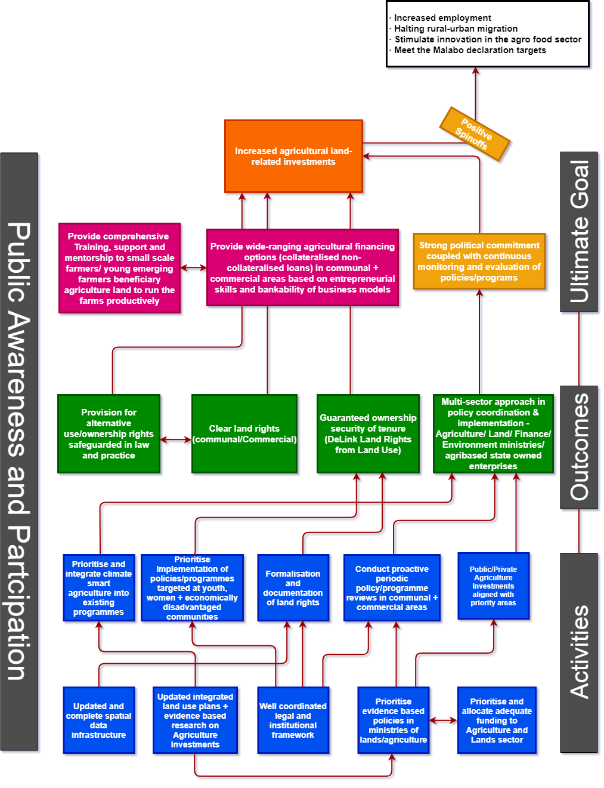

Multi-Sectoral Approach in Land Governance Implementation:

This recognizes the national strategic importance of African agricultural land and the role of smallholder farmers in achieving food security, poverty reduction and economic growth. The AU, through CAADP, recognised the agricultural sector as an important component for the transformation of Africa’s economies.
As for commercial agricultural land, the allocation criteria of land to the farmers should match the capability and ability of the farmer to fully utilize the land and its resources effectively. Time-bound post-resettlement support and effective monitoring should accompany allocation and acquisition of land. This safeguards the underutilization of the farmland. As access alone does not guarantee land productivity, land distribution per individual should then accompany other deliberate initiatives such as inputs.

Section B: Methodology for the Adapted Land Governance Assessment Framework (LGAF)
Under the LGAF, land governance is defined as the process by which decisions are made regarding access to and use of land, the manner in which those decisions are implemented and the way that conflicting interests in land are reconciled. Key elements of the definition include decision-making, implementation and conflict resolution, with dual emphasis on process and outcomes (World Bank, 2013). The aforementioned key elements are used as themes of assessment in the LGAF. Specifically, the following are the four assessment themes of the LGAF:

- Recognition and respect for existing rights (legal and institutional framework): the ways in which property rights to land (for groups or individuals) are defined and can be exchanged and transformed;
- Land use planning, management and taxation: the way in which public oversight over land use, land management, and taxation is exercised; the type of land that is state owned;
- Public provision of land information: the nature and quality of land ownership information available to the public and the ease with which it can be accessed or modified; and
- Dispute resolution and conflict management: the way in which disputes are resolved and conflict is managed.
The adapted framework also assesses the status of land governance in Namibia based on the four themes highlighted above. Under the LGAF, the four thematic areas are operationalised by defining nine assessment panels. These nine panels together provide a relatively exhaustive assessment of land governance issues relevant to most developing countries, including Namibia. These land governance issues are traditionally dealt with separately from each other. The nine panels cover the basic principles of land governance. The following are the nine panels that are defined by the LGAF:
- Panel 1: Land tenure recognition
- Panel 2: Rights to forest and common lands and rural land use regulations
- Panel 3: Urban land use, planning, and development
- Panel 4: Public land management
- Panel 5: Transparent process and economic benefit: transfer of public land to private use follows a clear, transparent and competitive process.
- Panel 6: Public provision of land information: registry and cadastre
- Panel 7: Land valuation and taxation
- Panel 8: Dispute resolution
- Panel 9: Review of institutional arrangements and policies
With the exception of Panel 3, 4 and 5, some of the indicators from the rest of the panels are relevant for land governance assessment within the context of the NAIP. Therefore, the adapted framework has six panels, instead of nine panels. Each panel has several indicators. Each indicator is further broken down into a number of “dimensions” with pre-coded statements/questions that seek to map out the experiences of key informants (on a scale from A to D) on the current status of land governance in a country with respect to the nine assessment panels (and hence the five thematic areas).

Implementation of the Adapted Land Governance Assessment Framework

Ideally, the Land Governance Assessment Framework (LGAF) should be implemented through a participatory approach involving key informants, who are carefully selected and categorised into the eight panels of the LGAF. The participatory approach is usually implemented over a 6-9 months period. However, the land governance assessment for the National Agriculture Investment Plan (NAIP) was constrained by time (i.e., only 15 days were allocated for the assessment). Therefore, the adapted framework was implemented using a rapid appraisal technique, where pre-coded statements for each dimension were answered or ranked based on the available literature. To a limited extent, the rapid appraisal technique also solicited information from key informants in the land and agriculture sector in Namibia. Each dimension as an indication of the adapted framework will be presented as highlighted in Table 14, below. The upper part presents a description of the dimension and the four pre-coded statements of governance assessment (on a scale from A to D or 1 to 4), from which a final choice has to be made by the panel. The lower part presents an analysis based on the information gathered, from secondary information sources, on the status of land governance in Namibia. The assessment and analysis presented below each LGAF table is complemented by inputs from key informants and secondary data. The analysis that will be presented in the lower part provides the justification for the ranking. Based on this analysis, recommendations will be made on how land governance in Namibia can be enhanced/improved so that it can act as a foundation for unlocking and promoting investments into the Namibian agriculture sector. It is expected that policy recommendations will be made for all dimensions with a C or D rank.

In addition to secondary data and the adapted LGAF, two consultative meetings also inform the assessment. The first one was the Malabo Domestication Country Convening in Windhoek, Namibia between the 11th to 14th February 2019. Delegates comprised of government officials, academia, researchers, statisticians, youth groups, farmers association/union, development agencies such as Food and Agriculture Organisation (FAO) and Japan International Cooperation Agency (JICA). The meeting was coordinated by PEM consult. The second consultative meeting was a brainstorming session themed “Potential, Purpose and Scope of a Strategy for the Agriculture Food Sector in Namibia” held in Windhoek from 16th to 17th April 2019.

Assessment of Land Governance in Namibia

Clarity of institutional and legal mandates

Table 2: Clarity of institutional and legal mandates
Clarity of Mandates
LGI | # | Indicator | A | B | C | D
5 | i | Separation of policy formulation, implementation, arbitration roles
5 | ii | Differentiated mandates across institutions
5 | iii | Differentiated responsibilities across levels of government
5 | iv | Information sharing across institutions

Although there is separation of institutional roles among the various government departments dealing with agricultural land, some overlaps and duplication of functions persist. This is because of the ignorance of some institutions regarding the limits of their responsibilities. Another challenge observed in the assessment is that while policies and regulations may be clear in theory, institutions tend to operate in silos. This is evident in the way that, for instance, the Ministry of Land Reform and the Ministry of Agriculture seem to operate. Although the mandate of the two ministries, in their strategic plans, is to alleviate poverty, in practice there is need for harmonising certain functions to increase the chances of achieving the objective of poverty alleviation. Vertical and horizontal overlap is particularly a concern across the local, regional and national agencies/commissions that results in long and sometimes redundant procedures.
The case in point here is the long and bureaucratic procedure of the national resettlement programme. Additionally, there is a lack of harmony among legislations in order to successfully complement collective or mutual requirements, that is, Traditional Authority Act (Act 25 of 2000), Communal Land Reform Act (Act 5 of 2002) and Deeds Registries Act (Act 47 of 1937). It is hoped that the Land bill will address such challenges to create clarity and harmony in legal and institutional arrangements.

Transparency of Land Use Rezoning in Communal Areas

There is currently a programme to develop a land use map, through the Integrated Regional Land Use Planning (IRLUP). The IRLUP is based on the bottom-up planning approach involving all relevant stakeholders in the planning and creation of geographical information system (GIS) database. This process is still ongoing in all the various communal areas across the country. Therefore, 50% to 70% of the land that has had a change in land use assignment in the past 5 years has changed to the intended use. The processes for rezoning are public and partially clear with mechanisms in place to safeguard existing rights, with minimal compensation in case of loss in areas where land is to be restricted or used for public purposes such as educational or health facilities. This is especially evident in expanding towns located in close proximity to communal farming areas. The percentage of the share of land set aside for specific use but used for a non-specified purpose in contravention of existing regulations is, however, not known. In summary, a land-use plan should address the following:
- Which land use is applicable and where to protect valuable resources;
- Which land use needs to be changed to maximise the use of land;
- Where to direct growth in a sustainable manner;

Land Tenure Recognition

Table 3: Recognition of land rights
Recognition of land Rights

LGI | # | Indicator | A | B | C | D
1 | i | Land tenure rights recognition in rural areas
1 | ii | Land tenure rights recognition in urban areas
1 | iii | Rural group rights recognition
1 | iv | Urban group rights recognition in informal areas
1 | v | Opportunities for tenure individualization
Based on experts’ responses and literature, the existing legal framework recognises and protects the rights held by 70% to 90% of the rural population. The communal land reform Act of 2002 provides for the allocation of rights to communal land. There are three types of tenure systems which exist in communal areas, these are, customary, leasehold and occupational. Communal land registration is still ongoing and out of the estimated existing 245,000 communal land claims, 158,156 land parcels were mapped and approximately 119,227 communal land rights have been registered as at 2018. Out of the 119,227 communal land parcels that have been registered, 1,204 comprised of leasehold rights. Leaseholds in communal areas are regarded as secure, registrable, transferrable, inheritable and mortgageable. The leaseholds are primarily for business or commercial purposes. Commercial purposes exclude agricultural uses.
Occupational land rights are for non-profit making organisations such churches, schools and community gardens. Groups can apply for rights under any of the three categories. Whereas the group should have an established legal entity such as a close corporation that would apply for the land right. The group rights have been implemented and most groups apply for leasehold rights because they are business making entities. The majority of land parcels that have not yet been mapped and registered are located in Kavango East, Kavango West and Otjozondjupa regions. To expedite the process of mapping and registration, additional resources in the form of manpower and finance are needed as well as being cognisant of different farming and cultural practices. In addition, communal rights to land and natural resources are partially legally recognised and protected in practice. One of the major issues for this is the continuing problem of illegal fencing in communal areas restricting the use of certain common pool resources by local residents. The registration of communal land rights is hoped to yield the following benefits;
- Give security of tenure to land holders.
- Ensure that landholders have documentary proof of their rights to land that shows their boundaries and exact size of the legally allocated land parcel.
- Enhances the protection of women’s rights and vulnerable groups.
- Allows each parcel of land to be owned by one person at a time, which rules out any form of land grabbing.
- Helps communities to identify land that is not owned, use it as commonage, and help them protect common pool resources like forestry, grazing land and water resources.
- Avails a right for compensation when the parcel or part of it is claimed by the government for building of new roads, town expansion or any other development.

Public Provision of Land Information

Table 4: Completeness of registry information
Completeness of Registry Information
LGI | # | Indicator | A | B | C | D
16 | i | Mapping of registry records
16 | ii | Relevant private encumbrances
16 | iii | Relevant public restrictions
16 | iv | Searchability of the registry
16 | v | Accessibility of registry records
16 | vi | Timely response to requests

Namibia has laid a good foundation concerning the legal and institutional framework through the enactment of the Land Survey Act (Act 33 of 1993), Statistics Act (Act 9 of 2011), the National Spatial Data Infrastructure Policy of 2015 –– and other sectoral laws that guide and facilitate the collection, management and distribution of spatial data. These and other reforms are an indication of commitment by the Namibian government to improve the use of spatial data for effective and efficient decision-making, which will lead to improved land governance and economic growth. Therefore, the land information system in Namibia is reliable, especially when compared to certain African countries.

Participants in the assessment were of the opinion that there are some links in place for virtually all types of land information (courts, banks and registries) but checks on the legitimacy of transactions that affect certain parties' land rights are only performed ex-post. The challenge is the lack of synchronisation of the spatial data. Furthermore, 90% of the ownership information in freehold/commercial areas in the registry/cadastre is up to date. On the contrary, approximately 50% - 70% of the ownership information in communal areas is up to date since the commencement of registration of communal land rights.

All the ownership information in the registry can be classified as reliable because they contain complete land records, including the technical and legal description of the title/certificate of occupancy registered.

For all land parcels that fall within freehold land, any encumbrances (e.g. mortgages) on it is recorded and can be verified at low cost by any interested party, such as banks, insurance companies or the buyer. Relevant public restrictions and charges are also recorded in a consistent and reliable manner. Most, if not all land registries are now computerised using geographical information system software. These run concurrently to the paper-based system. Both the computerised and paper-based systems are searchable, using the erf number of the landholder. Fees for searching or verifying records in the deeds registry are also relatively affordable, approximately N$50 (€3.07) per search.

Due to privities of contract, not all information recorded in the registry is open to the public. Therefore, for all to access certain spatial information, one needs to make a written request to the Executive Director in the Ministry of Land Reform (MLR). These requests for access to land information in the registry can take a long time, as it depends on how long it takes the Executive Director to either approve or decline a request.

Respect for and Enforcement of Land Rights

Table 5: Enforcement of rights
Enforcement of Rights
LGI | # | Indicator | A | B | C | D
2 | i | Surveying/mapping and registration of claims on communal or indigenous land
2 | ii | Registration of individually held land parcels in rural areas
2 | iv | Women’s rights are recognized in practice by the formal system (urban/rural)
2 | vi | Compensation due to land use changes

While the rights of freehold land is fully respected and enforced through the Agricultural (Commercial) Land Reform Act of 1995, communal land rights are only recognised by customary law and once they are registered, they are then recognised by statutory law under the Communal Land Reform Act of 2002.

Land in communal areas is vested in the state and administered by the 12 communal land boards and the relevant traditional authority. Currently, communal land-owners only have usufructuary rights on their land. This essentially means that the land cannot be used as collateral to invest in the land for agricultural purposes. However, the Agricultural Bank of Namibia (Agribank) introduced two non-collateralised products to assist both subsistence and commercial farmers owning land in communal areas. Other private commercial banks are sceptical about taking the risk to loan money in communal areas, since the land or agricultural property cannot be sold in case of a default in repayment. The assessment shows that the law provides opportunities for holding land under customary, group, or collective tenure to fully or partially individualise land rights. According to the Ministry of Land Reform, it costs N$75.00 (€4.6) to apply and obtain a customary land right certificate. This is relatively simple and cost effective. Furthermore, ownership and registration of joint property is also recognised by law on both freehold and customary land.

Before the National Land Policy came into effect in 1998, women in communal areas did not own communal land rights. By 2016, of the 73,287 registered communal land rights, 41.5% (30,414) were registered in the names of women, individually or jointly. The national Land Policy, Communal Land Reform Act of 2002 and the Constitution of the Republic of Namibia, Article 95 (a), gives all genders equal rights and freedom to own communal land rights. However, the assessment shows that even though there is equality of women’s property rights to those of men as established by law, there are considerable limitations to exercising such rights in practice. This is mainly attributed to existing traditional and cultural practices and beliefs that entrench patriarchal privileges.

Agriculture Land Valuation

Table 6: Transparency of valuation

Transparency of Valuation
LGI | # | Indicator | A | B | C | D
10 | i | Clear process of property valuation
10 | ii | Public availability of valuation rolls

The assessment shows that the lack of a valuation regulatory body in Namibia is of great concern. Namibia has a growing number of property valuation professionals.

The lack of adherence to neither local nor international standards leads to variations in the rates applied to value agricultural land. This is an important function in agriculture investments, as it determines the value on which financial institutions loan money to farmers. Equally important is the need to have a clear and standardised process to determine how much should be paid in land taxes. Any discrepancies in the valuation of agricultural land can lead to objections and ultimately litigations in the courts of law, a situation that has previously happened in Namibia with serious negative financial implications on both the state and the farmers.

The valuation rolls are publicly accessible for inspection before they are put into effect. Due to the vast and sparsely populated landscape, there is need to increase human capacity to conduct valuations of farm properties.

Justification for Expropriation of Agricultural Land

Table 7: Transparency of procedures

Transparency of Procedures
LGI | # | Indicator | A | B | C | D
14 | i | Compensation for expropriation of ownership
14 | ii | Compensation for expropriation of all rights
14 | iii | Promptness of compensation
14 | iv | Independent and accessible avenues for appeal against expropriation
14 | v | Appealing against expropriation is time-bounded

The Constitution of Namibia, under article 16, guarantees that (1) no one may be deprived of property except in terms of the law of general application, and no law may permit arbitrary deprivation of property (2) property may be expropriated only in terms of the law of general application;

(a) for a public purpose or in the public interest;

(b) subject to compensation, the amount of which have either been agreed to by those affected or decided or approved by a court.

With respect to agricultural land, article 14(2) (a-d) provides for the compulsory acquisition of agricultural land classified as under-utilised, excessive or acquired by a foreign national, or land where the application of the willing-seller, willing-buyer principle has failed.

In view of the above, the assessment shows that there is less than 10% of land expropriated in the last 3 years that is used for private purposes. In fact, the existing legal framework restricts the expropriation of land for private use. The expropriated land mentioned above applies mainly to communal land. There are currently no existing legal procedures to determine compensation payable to communal landholders whose property is expropriated by the state. Therefore, a Cabinet approved Compensation Guideline is used for this purpose. For freehold areas (agricultural farm-land), expropriation is implemented under Section 25 of the Agricultural (Commercial) Land Reform Act of 1995. The communal land expropriation occurs in cases where the state or local authority requires land for town expansion or other capital projects such as schools, clinics or hospitals that are beneficial to the public or community. Therefore, more than 70% of the land that has been expropriated in the past 3 years has been transferred to its destined use. In cases where individuals or communities are aggrieved, there is recourse at the local level through the land boards and traditional authorities or using the lands tribunal or conventional courts.

In cases where land is expropriated, compensation, in kind or in cash, is paid for some unregistered rights (such as possession, occupation etc.). However, those with other unregistered rights (which may include grazing, access, gathering forest products etc.) are not paid. The major contention here is how just is “just compensation”? There is evidence of disputes over the inadequacy of compensation paid to affected individuals or communities. Other areas of concern are disputes between local communities and traditional authorities in the process of deciding the land to be allocated for expropriation. In addition, people lose their land rights to the public interest of land use change and communal land development projects while receiving just compensation in return.

Transparency of Expropriation Procedures

On average, Namibia scores poorly on the transparency of the expropriation processes and procedures, especially in communal areas and in some well documented cases of commercial agricultural land. Although Article 16 (2) of the Namibian constitution provides for the expropriation of property in the public interest by the state subject to payment of “just compensation”, there have been cases where compensation and procedures followed had been contested. Thus, procedures for compensation in communal areas are not clear, especially for the local communities that may not have access to information to understand the process of expropriation and compensation. While the ultimate goal of the state is to alleviate poverty through land redistribution, some of the decisions taken through the expropriation procedures may have put poor people in a worse off situation and inadvertently wasted state resources. In addition, the cost of undertaking expropriation has been so high, because of litigations where procedures have not been transparent. The cases in point here are the expropriation of Ongombo West farm, Okorusu/Marburg farms and the Kessel case. These cases underpin the fact that there is neither transparency nor clear administrative rationality when it comes to expropriation of agricultural commercial land.

Resettlement Programme in Maps

Figure 4: Total number of resettled beneficiaries issued with lease agreements per region  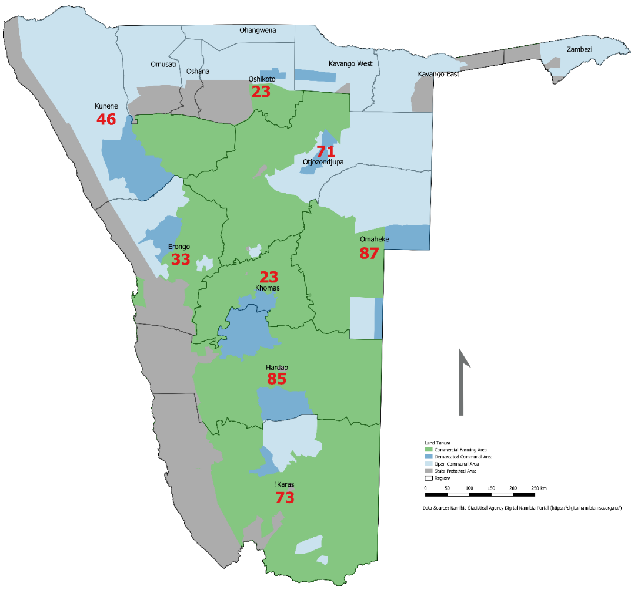 | Figure 5: Farms acquired for resettlement programme in communal and commercial areas (2016/17)  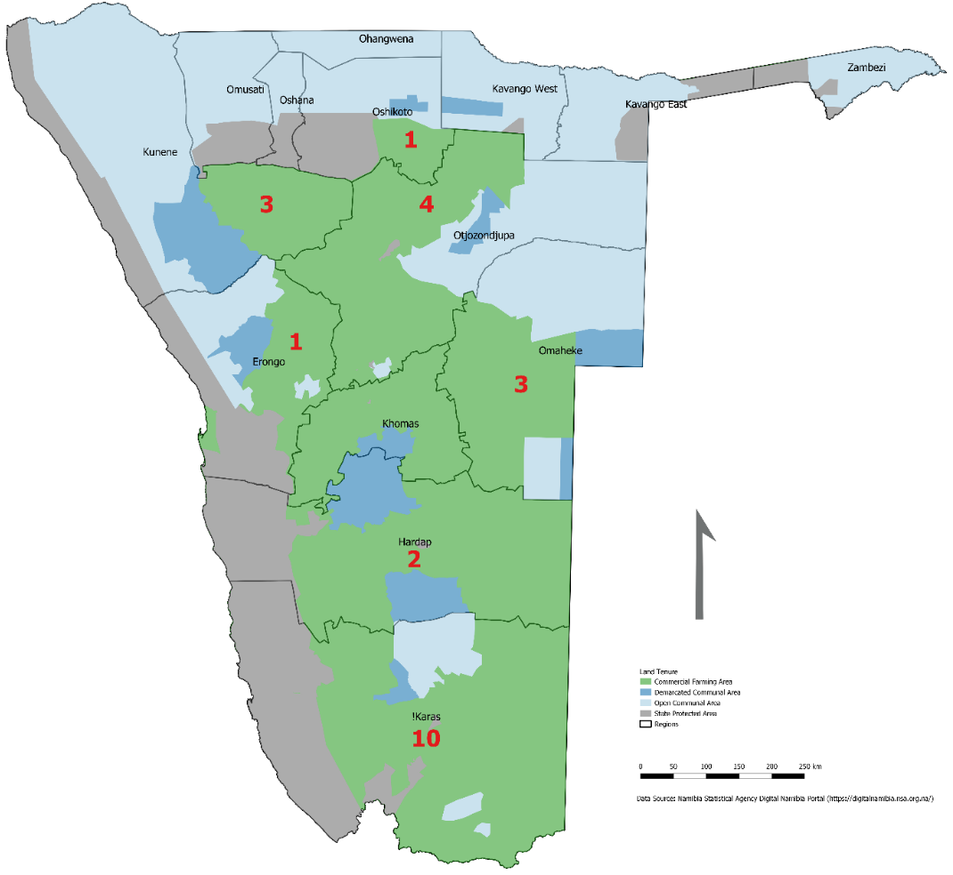

Figure 6: Farms acquired through national resettlement programme  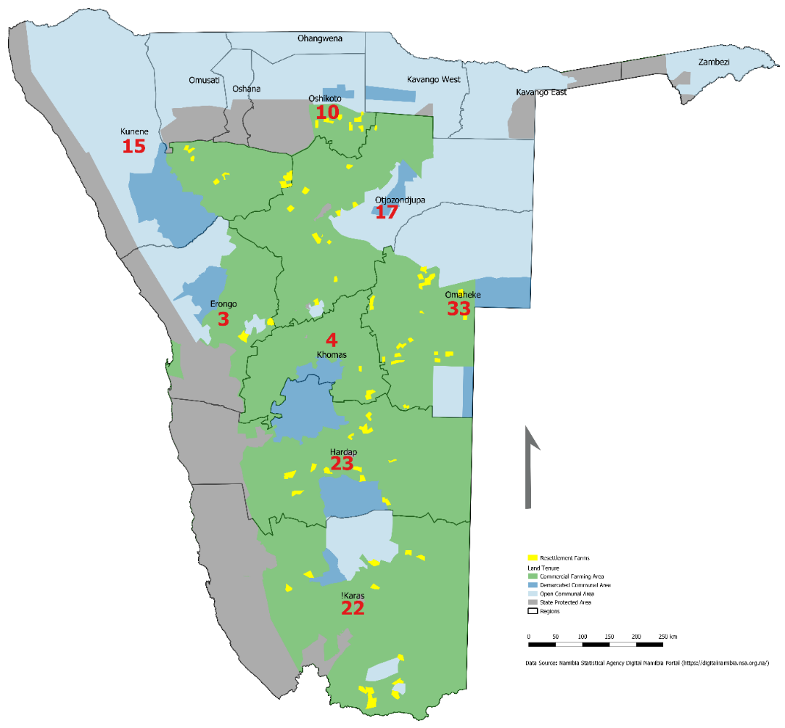 | Figure 7: Land reform beneficiaries in Namibia  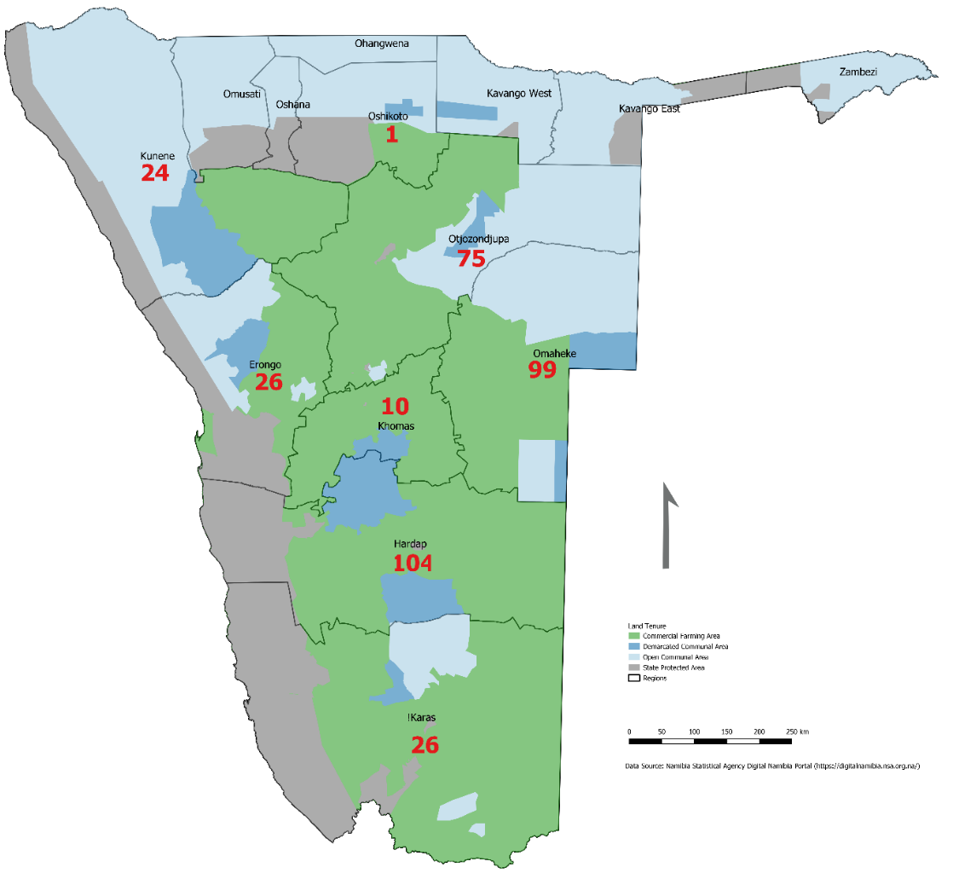

Figure 8: Lease agreements signed in communal and commercial areas (2016/17)
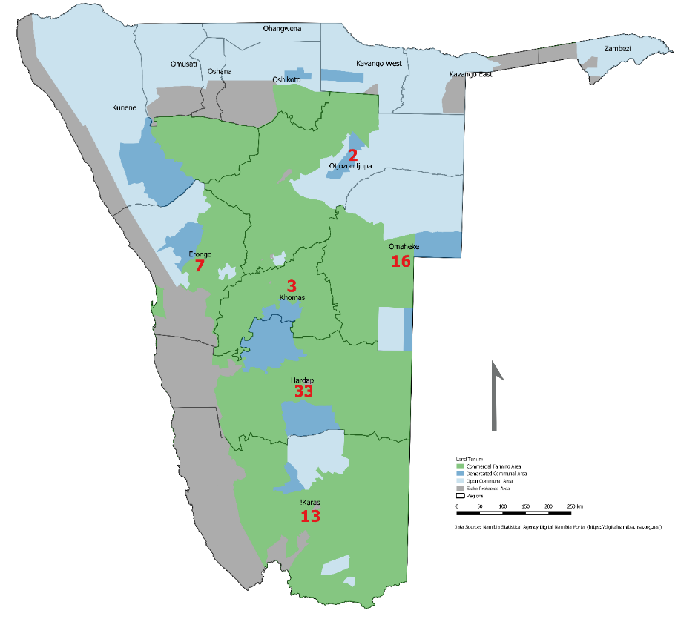

National Resettlement Programme (NRP)

Since 1990 until 2001, the resettlement programme was focused on a social welfare model which included the integration of different groups as follows; ex-combatants, ex-Kovoet, displaced people, San communities left in the former South African army barracks, farm workers dumped along the roads, Omitara group, Berg Aukas group and Botswana returnees. The two main pieces of legislation spelling out the aims and objectives of the land reform are the National Resettlement Policy of 2001 and the National Land Policy of 1998.

The NRP is a key part of the land reform in Namibia. One thing that is fully agreed by all stakeholders in the implementation of Namibia’s NRP is that it is slow (see Amoo & Harring, 2013; Lohmann et al., 2014; William et al., 2016; Sakaria, 2016). See geographical information system maps above (figure 4 – 8). It is very clear that resettlement is implemented in freehold/commercial areas, where the state acquires agricultural land for redistribution and resettlement to previously disadvantaged Namibians. There are concerns regarding the implementation of NRP to achieving land reform objectives.

Several factors have been identified to be militating against the quick delivery of land under the reform programme. They include factors such as legislative impediments, rigidity of the process, high land prices, and lack of human resource capacity. Without addressing the factors highlighted, accelerating investments in agriculture will be an uphill battle. The process in its current form lacks urgency, leadership, and human resource capacity. Bureaucracy and poor communication also pose impediments to its on-time implementation.

Cost-Effectiveness, Accessibility, and Sustainability

Table 8: Cost effectiveness, accessibility and sustainability
Cost Effectiveness, Accessibility, and Sustainability
LGI | # | Indicator | A | B | C | D
18 | i | Cost of registering a property transfer
18 | ii | Financial sustainability of registry
18 | iii | Capital investment in the system to record rights
19 | i | Schedule of fees for services is public

It is difficult to assess the financial sustainability of land registries since most of them operate within land ministries (Ministry of Land Reform, Ministry of Urban and Rural Development, Ministry of Works and Transport, Ministry of Agriculture, Water and Forestry). Ideally, land registries deposit their revenues into the central treasury, the money is later appropriated through the budget. Nonetheless, land taxes for agricultural land are collected successfully and this is a good source of income for the Ministry of Land Reform. To ensure taxes are paid, the legislation is well enforced. No transfer of commercial farms can take place without meeting the condition of a land tax clearance certificate, which means that the land taxes have been settled and are up to date. Loopholes do exist, and certain farmers try to transfer commercial properties through donations (bequeathing) to avoid paying land taxes.

Dispute Resolution and Conflict Management

Table 9: Assignment of responsibility for dispute resolution
Assignment of Responsibility for Dispute Resolution
LGI | # | Indicator | A | B | C | D
20 | i | Accessibility of conflict resolution mechanisms
20 | ii | Informal or community based dispute resolution
20 | iii | Forum shopping
20 | iv | Possibility of appeals

Land conflicts occur in many forms. In Namibia, there are conflicts between individuals, individuals and the state, individuals and local authorities, local authorities and the state, traditional authorities and communal land boards, agricultural corporations and the state and agricultural corporations and the local communities. There are isolated, and in most instances, well documented cases of land related conflicts in Namibia. With respect to freehold land, there is a clear assignment of responsibility for conflict resolution. On the other hand, there are still ambiguities on resolving certain conflicts emanating from communal land. Due to the increase in natural population in certain rural communities as well as the need for town expansion, there have been reported cases of land conflicts in communal areas.

Therefore, there are parallel avenues for dispute resolution. However, cases cannot be pursued in parallel through different channels and evidence and rulings may be shared between institutions to minimize the scope for forum shopping. In addition, institutions for providing the first instance of conflict resolution are accessible at the local level in less than half of communities. Nevertheless, where these are not available informal institutions perform this function in a way that is locally recognised. Through communal land boards, an informal system or community-based system makes decisions that are not always equitable but have recognition in the formal judicial or administrative dispute resolution system. In cases where the community-based conflict resolution system fails, a process exists to appeal rulings on land cases at high cost. Depending on the complexity of the case and the parties involved, it may take a long time to resolve. The same is true for cases that pertain to freehold agricultural land. It is difficult to assess the length of the land disputes as it depends on the complexity of a case.

The non-conventional institutions for addressing land-related conflicts include the traditional authorities or headmen and family gatherings. These institutions are less expensive than formal ones and thus more accessible. In addition, the Ministry of Lands, through the Directorate of Land Reform (Division of Land Boards and Tenure Advice), provides administrative functions to both the Lands tribunal and Appeals tribunal.
Tribunals are mandated to carry out the following functions:
- decide any appeal lodged with it in terms of any provision of the Communal Land Reform Act (Act No. 5 of 2002),
- consider and give a decision on any application made to it in terms of any provision of the Communal Land Reform Act,
- generally, inquire and adjudicate upon any matter which is required or permitted to be referred to it under any provision of this Act or any other law,
- any decision, order or determination of the Lands Tribunal may be executed as if it were a decision, order or a determination made by the High Court of Namibia.
The failure or unsatisfactory resolution of land-related conflicts in communal areas often leads to the transfer of such cases to formal institutions such as the land board. Once the case is unable to be resolved at that level, it is then forwarded to the land tribunal. Since the rulings emanate from the lower “courts” or traditional authorities, evidence may be shared between institutions to minimise the scope of forum shopping.
The Appeals tribunal is only approached once the judgement has been passed and the person is not happy with the judgement. Therefore, the Appeals tribunal fights for the revocation of the case to ensure that the judgement was indeed fair.

Large-Scale Land Acquisitions

Table 10: Large-scale acquisition of land rights
Large-scale Acquisition of Land Rights
LGI | # | Indicator | A | B | C | D
PLI | 1 | Most forest land is mapped, and rights are registered
PLI | 2 | Conflicts generated by land acquisition and how these are addressed
PLI | 3 | Land use restrictions on rural land parcels generally  identifiable
PLI | 4 | Public institutions in land acquisition operate in a clear and consistent manner
PLI | 5 | Incentives for investors are clear, transparent, and consistent
PLI | 6 | Benefit sharing mechanisms for investments in agriculture
PLI | 7 | Direct and transparent negotiations between land right holders and investors
PLI | 8 | Information required from investors to assess projects on public/community land
PLI | 9 | Information provided for cases of land acquisition on  public/community land
PLI | 10 | Contractual provisions on benefits and risk-sharing  regarding acquisition of land
PLI | 11 | Duration of procedure to obtain approval for a project
PLI | 12 | Social requirements for large scale investments in agriculture
PLI | 13 | Environmental requirements for large scale investments in  agriculture
PLI | 14 | Procedures for economically, environmentally, and socially  beneficial investments
PLI | 15 | Compliance with safeguards related to investment in agriculture
PLI | 16 | Procedures to complain if agricultural investors do not  comply with requirements
The Agricultural (commercial) Land Reform Act (Act 6 of 1995) regulates the acquisition of agricultural commercial land by foreign nationals or entities. Acquisition of agricultural land by foreign legal entities or natural persons is subject to written consent from the minister of lands. As at 2018, foreign nationals owned 281 commercial farms representing 1,256,899.86 hectares (see Table 11 below). Out of the 281 farms, 34 farms are owned in partnership with Namibians. There are two avenues in which agricultural land is made available for alienation, either through the willing-seller willing-buyer principle or through expropriation with just compensation. A legal and institutional framework exists to make land available to investors on an ad hoc assessment after consultation with the public. The state is considering passing a law that should prohibit foreigners (persons or legal entities) from acquiring agricultural land. The rationale is that agricultural land that comes on to the market must be alienated to “poor” Namibians. There is no singular policy that regulates the transfer of large-scale agricultural land. There is however, a process in place that considers mainly the national benefits. However, it tends to be unclear and sometimes bureaucratic. In cases where large-scale land is earmarked for acquisition, relevant institutions are clearly identified but may lack either capacity or incentives in ensuring that socially beneficial outcomes are achieved.

Table 11: Foreign ownership of agricultural land by nationality

Nationality of land owners | Size in hectares (Ha)
Americans | 82,023.90233
Austrians | 49,256.3692
British | 13,131.1255
Canadians | 3,233.3311
Chinese | 40.0012
Germans | 616,099.5969
Dutch | 4,166.2422
Italians | 13,088.7090
Russian | 28,871.7207
Spanish | 54,434.1673
South Africans | 349,813.1486
Swiss | 42,741.5504
Total | 1,256,899.8600

Absentee Landlords and Underutilization of Land

In a bid to make more land available for productive use, the ministry has introduced a progressive land tax to discourage multiple farm ownership. The Ministry of Land Reform prohibits the acquisition of a second farm by foreign nationals unless under special conditions. In order to effect these conditions, expropriation regulations were developed and gazetted in 2016. The underutilized land is among the target for expropriation as per the criteria. Based on information from the Ministry of Land Reform in 2018, seven underutilized farms were expropriated.

In cases where the large-scale land acquisition is in communal areas, restrictions on the use of land are clear and identified. For instance, where communities reside near gazetted forestry areas, Indiscriminate cutting of trees is prohibited and strictly regulated. Despite such regulations and due to harsh economic conditions, recent reports have shown that communities take the risk to cut timber for resale in order to earn a livelihood.

Procedures exist for large-scale land acquisition, which normally takes place as a means to achieve the national resettlement mandate. These procedures also apply in cases where the state intends to acquire land for large infrastructure projects such as the green schemes. Twelve Green Schemes have been established in Namibia, namely: Etunda, Hardap, Kalimbeza, Mashare, Musese, Ndonga-Linena, Orange River, Shadikongoro, Shitemo, Sikondo, Tantjieskoppe, and Uhvungu Vhungu. It is a cause for concern when huge tracts of land are acquired, especially if the land in question is in a communal area with human settlements. Compensation is usually low and does not cover the disturbance caused to the affected communities. Furthermore, because communal land belongs to the state, people occupying communal land cannot demand to be compensated for that land. Hence, the compensation only covers any improvements made on the land and any crops or fruits trees planted over the years. Consequently, conflicts may arise between the affected communities and the state, but also communities and leaseholder (s).

Section C: Consolidated substantive findings of the assessment

Based on the review of literature and expert interviews, comparatively, the land governance system in Namibia is for the most part progressive with intentions to improve the situation. However, to objectively assess the state of land governance in Namibia, we adapted the Land Governance Assessment Framework (LGAF) tool, by carrying out a rapid assessment by interviewing and administering questionnaires to expert informants. The rapid LGAF approach is adapted to specifically address issues linked to agricultural investments and productivity both in commercial and communal areas. A substantial number of indicators show that the land governance system in Namibia is on the right track with an aggregate score of 2/4 points as indicated in the scorecard assessment below.

Based on the review of literature, expert interviews and the land governance assessment framework, considerable progress has been made in the following key areas:
- Legal and Institutional Framework: A review of literature and the various statutes that pertain to land governance indicates that Namibia is one of the most progressive countries in this regard. Since independence, there have been several laws, regulations and institutions set up to administer and manage land in the country. Most of these institutions are well established with a presence at national, regional and local levels with participatory approaches embedded in them. The most novel one is the creation of Communal Land Boards to work in tandem with the national land ministry in assisting with administering land in communal areas.

- Political Commitment: While it is not easy to measure whether a particular government possess or exhibit the requisite political will or commitment to execute its mandate, one way to gauge this is perhaps, its willingness to fund particular governmental programmes. In this regard, the Ministry of Land Reform has had a fair share of budget allocations towards its programmes that are meant to achieve land reform objectives. State resources, the Land Acquisition Development Fund (LADF) and development partners have supported finances for the Land Reform Ministry’s operations and programmes. A significant amount of funding used for land reform programmes is sourced from the LADF. Land tax revenues form part of this funding which is collected annually from commercial farm owners. For instance, in 2018, the Ministry of Land Reform was allocated N$ 300 million. Out of this, the ministry acquired 12 farms measuring approximately 70,000 hectares of land for N$ 132 million. For the financial year 2018/19 Land Tax collected was N$ 19 million and government grant to LADF was N$ 117 million. For the financial year 2019/2020, the ministry hopes to spend approximately N$ 496 million in this regard.

Therefore, despite national budgetary constraints, there is clearly some level of commitment by the government to fund land related programmes that, if frugality and efficiency is applied, should ultimately translate into meaningful agricultural investments. The intention by the state should be commended. However, what should be made clear is to approach the issue of land-based investments in a business-like manner.

- Agricultural Finance: The Agricultural Bank of Namibia, which is wholly owned by the state, specialises in financing the entire agriculture value chain including land acquisition. In addition to providing financing for acquisition of freehold land, in 2018, Agribank launched two non-collateralised loan products for investments in communal land. Apart from merely advancing finance to farmers, the bank also, through an initiative called Farmers Support Project (FSP), mentors farmers in managing their farms as enterprises. Although the AgriBank may not be big enough to meet the needs of the entire nation, it is definitely an integral institution in supporting the agrarian agenda of the country. However, more could be done if the land market was properly regulated in communal areas to incentivize other private commercial lending institutions to begin advancing loans for agricultural investments.

- National Spatial Data Infrastructure: The government of Namibia has been at the forefront of supporting the establishment of the National Spatial Data Infrastructure (NSDI). This is an important component of the land governance system. Since its establishment, the NSDI has received high political will from the state in the process of its establishment. According to the Namibian Statistics Agency (NSA) annual report for the period 2017 to 2018, the NSDI received financial support of N$141 million for 2017 and N$ 112 million for 2018 in the form of government grants for its operations. There is enough evidence to show that to achieve sustainable development, there must be integration of cadastral and topographic data. This integration facilitates the sharing, access and utilisation of spatial data to better achieve any objectives and decision-making. Therefore, the NSDI is an important pillar to good land governance. However, it is not enough to have spatial data if the data is inaccessible. Equally important is to make the available data free of charge or at a minimal cost. This is because spatial data can then unleash a host of opportunities in the agro-food sector. Entrepreneurs, young and old, can tap into the entire value chain that will generate innovations from primary agriculture, food processing systems and markets.

Notwithstanding such progress, the goal of increasing investments and productivity in agriculture through an efficient land governance system is marred with a number of challenges that persist in the following areas:

- Harmonisation, Streamlining and Alignment: The issue of land governance has a much broader implication that goes beyond the Ministry of Land Reform. There is now ample evidence around the world that having the required legal and institutional framework to administer and manage land is not enough. This is because land governance and reform are a long and never-ending project. Moreover, the goal to ending hunger, increasing agriculture productivity, guaranteeing food security and at the same time correcting past colonial injustices is in itself a moving and complex target. Therefore, there must be realisation by the state to relentlessly review and harmonise the various strategies and policies that aim to achieve the national targets. Cardinal to this is ensuring that bloated process and procedures are made leaner and quicker at all levels of administration within the law. Redundant procedures must be completely removed or merged with other processes to reduce the time it takes to arrive at decisions. Such decisions would encompass all ministries and agencies that have a role in providing agricultural land and all its attendant aspects such as infrastructure and support services.

- Regulated Land Markets – Land markets allow land to be used by farmers who are more capable to earn the highest return from it, through mobility of scarce factors of production such as labour, draft power, implements, purchased inputs, management and entrepreneurial ability. Land markets are cardinal for various players in the agricultural value chain, such as, lending institutions, insurers, farmers and the state to collect any attendant revenues through taxes. Like many African countries, Namibia has broadly two tenure systems, freehold and communal tenure. For the most part, land markets under freehold work flawlessly with clarity of laws, regulations and procedures. Gaps exist in communal areas and recent studies show that there is an active land market in communal areas, albeit illegal.

This phenomenon is active, diverse and growing in communal areas. Traditional authorities control a substantial part of the market, while private individuals control the rest. Studies show that the link between money supply and demand for land is driving the land market in communal areas. It is therefore an incongruity to approach the administration of communal land in a simplistic manner. While subsistence and customary land management might have been appropriate decades ago, they are not suited to the needs of modern, monetised societies with a growing natural population. Current legal prescriptions such as the Communal Land Reform Act of 2002, are therefore at odds with processes embedded in communal areas today. To strengthen land governance in communal areas does not mean doing away with communal tenure, but rather strengthening it and providing laws and regulations that respond to current needs. The state is cautious about introducing land markets in communal areas, as this might leave rural communities landless. However, a tightly regulated land market could attract emerging farmers to either lease or acquire good agriculture farmland for increased agricultural investments. In addition to this is the need to administer and manage the commonage (grazing land, watering holes, forestry) much more closely and enforce firmly the implications/penalties of illegal fencing that deprive local communities from accessing resources that rightly belong to them for their livelihood.

- The Future of Agriculture – The growth of agriculture in Namibia needs rethinking by all relevant stakeholders. There is need to separate the enablers for agriculture, the state, and the business which comprises large and small-scale farmers. On one hand, the Republic of Namibia needs to provide the leadership and policy direction with clear implementation plans. On the other hand, entrepreneurs (agro-food sector) will need to be supported for them to contribute to agricultural investment. Central to this support is ensuring clear land rights that are guaranteed by law. This should apply to both freehold and communal land. In addition, there is a need to have a long and wide view of the potential of the agriculture sector and its contribution to the gross domestic product. Beyond ensuring the security of tenure, there is finance, markets, well-functioning land markets, climate smart agriculture, climate change and evidence-based policy formulation that equally need an equal amount of planning and attention. Without the amalgamation of the above highlighted factors, there will be marginal investments in agriculture, especially for communal based farmers.
Therefore, there is need to embrace a joint vision by all stakeholders in order to appreciate and seize both the challenges and opportunities that exist in the agriculture sector.

- Strengthening Existing Institutions – Poorly functioning public sector institutions and weak governance are major constraints to growth and equitable development in many developing countries. Good, effective and strong public sector institutions are cardinal for poverty reduction. Namibia has done considerably well in establishing institutions to administer and manage land. What is unknown is the effectiveness of these institutions in delivering the services that should spur agricultural growth and investments. Contrary to focusing on expenditure in the land sector, Namibia needs to evaluate the impacts of its programmes and policies. Firstly, 29 years after independence, are the policies in their current form still relevant in this ever evolving and complex environment? Secondly, if the programmes and strategies are not yielding the intended results, reviewing and evaluating such programmes must be done more deliberately and timeously. While the main goal to manage, administer and ensure equitable access to Namibia’s land resource continues to guide the agrarian reform, there is definitely need to relook certain existing programmes to ensure that they are more robust and benefit people that could ultimately positively contribute to agriculture productivity. To achieve this, there is need to have strong and effective institutions to deliver this mandate. Public institutions (Ministry of Land Reform, Ministry of Agriculture, Water and Forestry, Ministry of Finance, Agricultural Bank of Namibia, Ministry of Works and Transport) should therefore embrace an entrepreneurial approach at all levels with a view to creating multiple opportunities for players in the agro-food sector. This is not a short-term objective, but a long-term goal that will also change how the state views the contribution that agriculture could make to the country.

- Information Dissemination of Land Related Programmes - another area that requires improvement in the land governance system in Namibia is the public awareness of the various programmes that the Ministry of Land Reform is undertaking, such as the National Resettlement program, Land Acquisition program and the Post Settlement Support program. While the intention of such programmes is noble, there is a need to equally interrogate the extent to which such programmes benefit farmers who could potentially maximise returns on the limited farmland. The term farmers includes all types of farmers: skilled and experienced farmers, subsistence farmers, emerging young farmers and weekend farmers. The goal should be to give focus on farmers who view agriculture as a viable enterprise that feeds into the wider agro-food sector from acquisition of land, agriculture intermediaries to markets. The responsibility of the Ministry of Land Reform should therefore go beyond just acquiring land and redistributing it, but it should be closely linked to the processes of the entire value chain. The land ministry should therefore be interested in knowing what happens to a particular piece of land beyond issuing of the allocation letter. The lands ministry -must realise its importance and centrality in increasing investments in agriculture, not only in commercial areas but communal areas too. The game changer here could be targeting the citizenry that are genuinely interested in using agriculture as an engine to agriculture productivity. The main criteria, over and above the financial support or security of tenure, must be the entrepreneurial skill sets to run a farm, not as a hobby, but a tool to create value for the household and the nation. For the nation to attract such individuals, the sector needs a champion to drive the agenda or vision of redressing past wrong, achieving food security and reducing poverty. There is need to appreciate the importance of land services, particularly in the agriculture sector. The champion must ensure that looking into the future, there are streamlining procedures of land allocation, cost of documentation/registration of land rights and claims, especially communal rights. Such a person must also encourage or initiate innovations in land governance with the specific goal of making available land to all, but most specifically individuals who would make the most productive use of it.

- Quality over Quantity - There is an urgent need to critically rethink the agriculture sector, especially for subsistence and commercial farmers in communal areas. There must be a shift from thinking of agriculture as a way of life or as a pastime. Agriculture should be thought of as an enterprise, which should be managed and run profitably. This is especially true in a country like Namibia, where the two main factors that determine agriculture production are climate and land ownership. Therefore, despite a huge land mass of 824,290 km², the focus should be quality over quantity. This means that quality and productive agricultural land should be allocated to individuals who have shown their ability to farm productively and profitably. Additionally, agricultural land that is allocated should not be fragmented, but rather, optimal enough to increase yields.
- Embracing Research, Monitoring and Evaluation in Policy Formulation: It is not enough to merely allocate financial and human resources to a complex issue such as land governance. This is especially so in a country like Namibia whose current socio-economic state is rooted in its history of colonial injustices and inequalities. The recent discourse in the land and agriculture sector demonstrates the need for evidence-based policy formulation. Quality evidence (research) is produced by rigorous, independent and impartial research. Although this evidence (research) may not be particularly what the state would want to see, it is necessary for improving processes and regulations in the land sector. Without independent research and the ability to act on recommendations, then any policy formulation done may be trying to address problems that would have completely changed. For instance, it is important to objectively determine the portion of the Namibian population willing to engage in the agro-food sector, from primary farm production throughout the entire value chain. Additionally, out of those willing to embark on agriculture, how many have the requisite skills to meaningfully work the land productively to create employment, improve household and national food security? There are other questions that equally require answers, such as; to what extent do the resettled beneficiaries benefit the local and national economy? There is need to shift attention from expenditure made in the land sector, to the impacts (positive or negative) the programmes have on the less privileged in society. As an example, Table 12 below illustrates how the relevant stakeholders can use a widely accepted tool to monitor and evaluate land related policies and programmes that have an impact on agriculture productivity and investments in Namibia. This approach used in conjunction with the LGAF tool would be important to track the impact and progress of the land governance system in Namibia with specific focus on agricultural investments. Other examples of land related goals that could be measured and monitored with the logical framework are as follows:

Goal 1.0 To guarantee women’s access and secure ownership of land;

Goal 2.0 To prevent illegal fencing of communal land;

Goal 3.0 To better manage common pool resources such as forestland, grazing land, water resources;

Goal 4.0 To create functional and well-regulated land markets in communal areas;
Table 12: A sample of the logical framework
Objectives | Objectively verifiable indicators (OVIs) | Means of Verification (MoV) | Assumptions
Goal: To increase the number of emerging farmers (Commercial, Subsistence and Part time farmers) allocated resettlement land in Namibia. | Percentage of emerging farmers allocated resettlement land. | 1. List of resettlement beneficiaries.  2. Ministry of Land Reforms annual reports. | 1. Resettlement land is allocated to the intended beneficiaries (who are the less privileged Namibians).
Purpose: 1. To empower less privileged Namibians through ownership of productive agricultural land.  2. To increase agriculture investments by emerging farmers. | 1. This remains the objective of the GRN to empower landless Namibians with agricultural land.  2. Increase the number of less privileged Namibians to own agriculture land. | 1. Independent Land/farm audits.  2. Government records (Deeds office). | GRN remains committed to poverty reduction and increasing agriculture productivity.
Outcomes: 1. Increase Food security.  2. Create employment opportunities.  3. Generate revenue for GRN through tax and foreign exchange. | 1. Reduction in importation of food stuff that can grow in Namibia.  2. Increase the yield of agriculture productivity by 3% annually.  3. Increase in foreign exchange earnings by 3% annually.  4. Number of direct and indirect jobs created by emerging farmers per annum. | 1. Household food surveys.  2. Labour statistics in the agriculture sector.  3. Annual receipts in the agriculture sector.  4. Food and Agriculture Organisation Reports. | 1. Cooperation from other line ministries (Agriculture, Water and Forestry, Ministry of Works and Transport).  2. Interest from Namibians who are passionate about farming as an enterprise.
Inputs: 1. Productive agricultural land.  2. Support emerging farmers with finance and mentorship  3. Infrastructure (Roads, dams).  4.Awareness campaigns on resettlement programme.  6. Surveyed land.  5. Secure land rights. | 1. Number and type of support offered to emerging farmers.  2. Evidence of promotional programmes about National resettlement programme.  3. Number of resettlement farms surveyed per period.  4. Number of emerging farmers that have accessed finances.  6. Absence of land conflicts in resettlement land. | 1. Budget allocation for resettlement programme.  2. Loans advanced to emerging farmers  3. Local print and electronic media adverts on resettlement programmes.  4. Training workshops to mentor emerging farmers. | 1. Funding is made available to enable Ministry of Land Reform to buy agriculture land and make it available for emerging farmers.  2. The land is available for GRN to buy (willing seller-willing buyer principle or expropriation).  3. Training and mentorship is available.  4. If natural disasters occur, they have a minimal impact on the programme.  5. If there are clear, secure and transferrable land rights for a functional land market to allow for banks to provide financing.

Policy Recommendation Matrix
Based on the assessment of the land governance system of Namibia using the adapted LGAF, we are of the considered opinion that the following are some of the areas that require intervention. Some of these are low hanging fruits that do not require considerable resources while others are of a long-term nature requiring long term planning and resources to address.

Table 13: Policy Matrix
No. | Findings | Recommendation | Competent institution | Monitoring indicator
1 | Recognition of communal (indigenous) land rights and natural resources legally recognised but may not be protected. | Using legal provisions, enforce the recognition of communal land rights (commonage) and natural resources to empower local communities to access such land-based resources. | Ministry of Land Reform, Ministry of Agriculture, Water and Forestry, Ministry of Environment and Tourism, Ministry of Justice. | The number of policies and Acts focusing on communal land such utilisation as forestry land, grazing land, water sources.
2 | Individually held land in communal areas is not formally registered. | Accelerate the registration of communal land with a view to improving security of tenure (or the perception of security of tenure) that should encourage individuals to increase agriculture productivity and investments. Additionally, legally recognize and respect group communal rights as this may apply differently depending on cultures and traditions in the different regions. | Ministry of Land Reform, Ministry of Agriculture, Water and Forestry, Ministry of Environment and Tourism, Ministry of Justice, Ministry of Urban and Rural Development. | The number of cadastral surveyed erven (plots) registered as part of "communal land ownership individually or corporately".
3 | Women’s land rights are recognized by law, but there could be concern about the situation in practice due to cultural beliefs and practices about ownership of productive assets. | Develop and support awareness programmes to educate and empower women for their land rights and reinforce this with subsidized legal services (legal aid) in cases where their land rights are threatened. | Ministry of land Reforms, Ministry of Gender Equality and Child Welfare, Ministry of Land Reform, Ministry of Justice. | Engendering legislation on land and number of women with land held in their names.
4 | Unclear multiple rights (communal, agricultural lands, forestry area) over the same communal land and natural resources on these lands legally coexist. | Harmonise regulations and application in practice.  Standardise types of use, utilisation and purpose of land (which includes agriculture land). | Ministry of Land Reform in conjunction with Ministry of Agriculture Water and Forestry, Ministry of Environment and Tourism, Ministry of Works and Transport. | Unambiguous land rights in communal areas.
5 | Allocation of resettlement land to the previously disadvantaged landless Namibians. | Strengthen and create a credible and transparent vetting system for beneficiaries of resettlement land to avoid allocating land to individuals who can buy land through the Affirmative Action Loan Scheme (AALS). | Ministry of Land Reform, Ministry of Agriculture Water and Forestry, Agricultural Bank of Namibia. | Publicly available list of beneficiaries of resettlement land showing selection criterion.
6 | Survey and registration of resettlement land. | Expedite the survey and eventual registration of land allocated through the National Resettlement programme, that would make it possible for financial institutions to advance financing for investment. | Ministry of Land Reform in conjunction with Ministry of Agriculture Water and Forestry, Ministry of Justice, Agricultural Bank of Namibia. | Number of resettlement farms surveyed, and leasehold certificates issued to beneficiaries.
7 | Unclear process for appraisal of investment plans and untimely procedures to approve land-based investments. | Shorten and streamline the process of appraisal of investment projects to reduce the approval process within the confines of the law. | Ministry of trade and investments, Ministry of Land Reforms, Ministry of Agriculture Water and Forestry, Ministry of Works and Transport, Ministry of Environment and Tourism. | Reduced number of approval procedures across ministries and agencies.
8 | Streamline and expedite implementation of land redistribution programmes. | Review and revise the existing regulations to cut out redundancies in the procedures but still ensure transparency and adherence to laws. | Ministry of Land reform, Ministry of Agriculture Water and Forestry, Ministry of Works and Transport, Ministry of Justice. | Shortened and harmonised procedures and reduced number of days to allocate land.
9 | Conduct detailed impact evaluation studies to ascertain the effectiveness of land reform programmes such as the National Resettlement programme. | Institute independent detailed impact evaluation studies for all land related programmes, in order to ascertain the efficacy of such programmes. | Ministry of Land Reform in conjunction with Ministry of Agriculture Water and Forestry, National Planning Commission of Namibia and Ministry of Finance. | Number of detailed independent impact evaluation studies in at least five yearly cycles.
10 | Inadequate efficacy of institutions' capacities in order to provide quality and timely services. | Make available regular training opportunities (long and short term) for all staff at local, regional and national to among others appreciate the strategic position of land governance in economic development and particularly agricultural productivity and investment. | Ministry of Land Reform in conjunction with Ministry of Higher Education, Training and Innovation. | Number of suitably trained personnel in the Ministry of Land Reform placed in the right positions.
11 | Strengthening Intra-institutional coordination in the land expropriation process (with compensation). | Implement a streamlined process that links all relevant institutions in the expropriation process with a view to having short, yet robust procedures linking all relevant stakeholders. | Ministry of Land Reform, Ministry of Agriculture Water and Forestry, National Planning Commission. | An unambiguous procedure with reduced number of days for the expropriation process.
12 | Conflicts in both communal and commercial areas take a long time to resolve. | Adopt alternative methods of dispute resolutions, such as arbitration or mediation, that are cost effective and faster. | Office of the Ombudsman, Ministry of Justice, Ministry of Land Reform, Ministry of Agriculture, Water and Forestry. | Number of mediated and arbitrated cases.
13 | Overlaps and ambiguities in the responsibilities of the ministries and agencies dealing with land. | Engage all relevant stakeholders to review existing regulations and procedures to reduce overlaps and ambiguities. | Umbrella institution in charge of land governance, Ministry of Land Reform in conjunction with Ministry of Agriculture Water and Forestry, Ministry of Works and Transport. | Reduced number of regulations, steps or procedures or remove redundant steps in the existing procedures.
14 | Improve the dissemination of information about the existing land reform programmes. | Well packaged information and prioritise dissemination of information about land reforms with a view to attract competent farmers (Commercial, subsistence and part time farmers). | Umbrella institution in charge of land governance, Ministry of Land Reform in conjunction with Ministry of Agriculture Water and Forestry. | Number of print or electronic programmes to market land related services and programmes.
15 | Focus on improving quality of farmers rather than quantity of farmers allocated agricultural land. | Business like and stringent vetting process to select only farmers who demonstrate ability to efficiently utilize the land productively with some minimum entrepreneurial skills. | Umbrella institution in charge of land governance, Ministry of Land Reform in conjunction with Ministry of Agriculture Water and Forestry, Ministry of Industrialisation, Trade and SME Development. | Number of productive allocated farms breaking even or better.

Conclusion

Secure and equitable rights to land and natural resources are essential for meeting the targets of the Malabo Declaration and the achievement of the Sustainable Development Goals (SDG’s). The study reveals that there is need for optimism regarding the state of land governance in Namibia. This is because certain fundamental pillars of good land governance are in place and others just require improvement. However, there is an urgent need to critically review certain existing programmes in order to respond to the current challenges of lack of desired agriculture investments and productivity, especially in communal areas. Additionally, there is need to put in place mechanisms to monitor the impacts of the existing land related programmes so that the limited productive land resources are put to efficient use. Assistance, in terms of financing and technical support, is needed for farmers to have any chance of turning agriculture into an engine of economic development. Political influence should only go as far as creating the necessary legal and institutional framework for agriculture land-based investments to thrive. Therefore, any decisions made regarding how land is allocated and used and by whom, should be made on merit and with a business approach. At the core of agriculture investment are secure land rights, be it freehold or communal land. Certainty and the ability to transfer land rights in a regulated market will ensure that all relevant stakeholders can plan and invest for the ‘long haul’ without fear of arbitrary expropriation or indeed displacement by either private or state actors.

Bibliography
African Union. (2018). AU NAIP Toolkit for Malabo Domestication.
AUC (African Union Commission). (2014). Malabo Declaration on Accelerated Agricultural Growth and Transformation for Shared Prosperity and Improved Livelihoods. Addis Ababa, Ethiopia: AUC, 1(1), 1–12. Retrieved from https://www.resakss.org/sites/default/files/Malabo
Bruce, J. W. (1996). Country Profiles of Land Tenure.
Bugri, J. T. Ã. (2008). The dynamics of tenure security, agricultural production and environmental degradation in Africa: Evidence from stakeholders in north-east Ghana. Land Use Policy, 25, 271–285. https://doi.org/10.1016/j.landusepol.2007.08.002
Christensen, Å. (2015). The new Flexible Land Tenure Act : an update. (October 2015). Windhoek. Retrieved from http://ilmi.nust.na/sites/default/files/ILMI-CHRISTENSEN-The-new-flexible-land-tenure-act-An-update.pdf
de Vries, W., & Lewis, J. (2009). Are urban land tenure regulations in Namibia the solution or the problem? Land Use Policy, 26(4), 1116–1127. https://doi.org/10.1016/j.landusepol.2009.02.002
Engel, A. (2006). An institutional framework for land reform in Namibia. Namibia Natural Resources and Rural Development, 82. Retrieved from http://www.gtz.de/de/weltweit/afrika/namibia/1396.htm
EU Task Force on Land Tenure. (2004). EU LAND POLICY GUIDELINES.
French Development Cooperation. (2009). Land Governance and Security of Tenure Land Governance and Security of Tenure (Land Tenure and Development).
GIZ. (2015). The Land Delivery Process in Namibia, (September). Retrieved from http://www.the-eis.com/data/literature/The
Goldstein, M., & Udry, C. (2008). The Profits of Power: Land Rights and Agricultural Investment in Ghana. Journal of Political Economy, 116(6), 981–1022. https://doi.org/10.1086/595561
Gollin, D. (2017). Heterogeneity , Measurement Error, and Misallocation: Evidence from African Agriculture.
Good, I., & Land, P. (2012). The Land Governance Assessment Framework. The World Bank. Retrieved from www.worldbank.org
Government of Namibia. (2012). The Flexible Land Tenure Act No. 4 of 2012. Government Gazette of the Republic of Namibia. Retrieved from http://www.lac.org.na/laws/2012/4963.pdf
Hagos, H. G. (2012). Tenure (In) security and Agricultural Investment of Smallholder Farmers in Mozambique.
Huntington, H., & Shenoy, A. (2018). Does Insecure Land Tenure Deter Investment? Evidence from a Randomized Controlled Trial.
Janvry, B. A. De, Emerick, K., Gonzalez-navarro, M., & Sadoulet, E. (2015). Delinking Land Rights from Land Use: Certification and Migration in Mexico . American Economic Review, 105(10), 3125–3149. Retrieved from http://dx.doi.org/10.1257/aer.20130853
Kagwanja, J. (2012). Supporting Land Policies and Governance of Land Tenure to improve Agriculture Investments & Food Security Key Land Issues impeding Food Security and Sustainable Dev • Land issues in agriculture — low. In Global Forum on Agriculture Policy Coherence for Food Security in Developing Countries. Paris.
Kasita, M. (2002). Establishing Communal Land Registration in Namibia: The Process, Benefits and Challenges 1 Summary: 2 Background for the Land Registration. In Annual World Bank Conference on Land and Poverty 2011. Retrieved from https://www.oicrf.org/documents/40950/43224/Establishing+communal+land+registration+in+Namibia+the+process+benefits+and+challenges.pdf/ca758bc1-f116-1b0b-3793-ec1be6c4ad07
Legal Assistance Centre. (2005). A study on land tenure policy and securing housing rights in Namibia. Windhoek. Retrieved from www.lac.org.na
Lisher, J. W. (2018). Guidelines for Impact Evaluation of Land Tenure and Governance Interventions, (January), 1–42.
Martin, M. (2014). Africa Agriculture Transformation Scorecard: Performance and Lessons for the Southern Africa Development (Vol. 2018). Retrieved from www.resakss.org
Mendelsohn, J., Shixwameni, L., & Nakamhela, U. (2012). An overview of communal land tenure in Namibia: Unlocking its economic potential. Research & Information Services of Namibia, 16. Retrieved from http://www.the-eis.com/data/literature/Overview
Ministry of Agriculture Water and Forestry. (1995). National Agricultural Policy. Windhoek. Retrieved from http://www.mawf.gov.na/
Ministry of Agriculture Water and Forestry. (2015). Namibia Agriculture Policy. Government Gazette of the Republic of Namibia. Windhoek. Retrieved from http://www.mawf.gov.na/
Ministry of Agriculture Water and Forestry. (2014). Strategic Plan 2012/13 to 2016/17. Retrieved from www.mawf.gov.na
Ministry of Land and Resettlement. (2013). Resttlement Criteria, 18.
Ministry of Land Reform. (2018). Resolutions of the Second National Land Conference 1st-5th October 2018. Windhoek: Ministry of Land Reform. Retrieved from http://www.mlr.gov.na/
Ministry of Land Reform. (2001). Rural Resettlement Policy. Windhoek. Retrieved from http://www.mlr.gov.na/
Ministry of Land Reform. (2017). Annual Land Reform Statistics 2017/18. Windhoek. Retrieved from http://www.mlr.gov.na/
Ministry of Land Reform. (2017). Revised national resettlement policy 2018 – 2027. Windhoek. Retrieved from http://www.mlr.gov.na/
Ministry of Land Reform. (2018). The State of Land Reform since the 1991 National Conference on Land Reform and the Land Question. In Second National Land Conference (p. 79). Windhoek. Retrieved from http://www.mlr.gov.na/documents/20541/283371/Minister+Report.pdf/a23d7eff-526d-4847-ae18-a2a38f845fbd
Ministry of Land Reform. (1998). National Land policy. Windhoek. Retrieved from http://www.mlr.gov.na/
Ministry of Land Reform. (2018). Ministry of Land Reform Strategic Plan 2017/18 to 2021/22. Windhoek. Retrieved from http://www.mlr.gov.na/
Ministry of Land Reform. (2013). Resttlement Criteria. Wellington. Retrieved from http://www.mlr.gov.na/
Ministry of Land Reform. (2004). Background Research Work and Findings of the PTT Studies. Windhoek. Retrieved from www.mlr.gov.na
Ministry of Land Reform. (2018). Land Tax and Valuation System – Case Study of Namibia. In Second National Land Conference (pp. 1–39).
Molen, P. V. (2008). A Comparative Study to Land Policy in 9 Countries in Africa and Asia. A Comparative Study to Land Policy in 9 Countries in Africa and Asia. In FIG Working Week 2008 (pp. 1–46).
Namibia Institute for Democracy. (2009). Communal Land Registration. Windhoek: Namibia Institute of Democracy.
Namibian Statistics Agency. (2018). Namibia Land Statistics - Booklet. Windhoek. Retrieved from https://cms.my.na/assets/documents/NamibiaLandStatistics2018.pdf
Norfolk, S., & Tanner, C. (2007). Improving tenure security for the rural poor. Support to the Legal Empowerment of the Poor. Retrieved from ftp://ftp.fao.org/sd/sda/.../sdar/sard/Mozambiquecase.pdf
Odendaal, W., & Werner, W. (2010). Livelihoods after land reform.
Policy, L., & Timo, W. (2018). Towards a Theory of Metagovernance of Land: Fundamentals and Prospects, Walter Timo de. Journal of Land Policy and Governance (JLPG), 1(1), 26–36.
Project Oracle. (2014). Developing a Theory of Change for your project. London.
Regional Strategic Analysis and Knowledge Support System. (2015). Tracking Progress of African Agriculture Toward CAADP Targets ReSAKSS. Retrieved from www.resakss.org
Republic of Namibia. (2014). Namibian Constitution.
USAID. (2004). Ethiopia Land Policy and Administration Assessment.
World Bank. (2010). Land Governance Assessment Framework Manual.
World Bank. (2013). 2013 Results Framework and M & E Guidance Note. Retrieved from http://siteresources.worldbank.org/PROJECTS/Resources/40940-1365611011935/Guidance_Note_Results_and_M&E.pdf
World Food Programme. (2017). Namibia Country Strategic Plan (2017 – 2022).
Zambezi Regional Council. (2018). Regional Consultations in Preparation for the Second National Land Conference.

List of Legal Instruments and Policies

- Development of Legal Frameworks and Policies
- Brief Description of Acts and Policies
- The Agricultural (Commercial) Land Reform Act (Act 6 of 1995)
- Communal Land Reform Act (Act 5 of 2002)
- Flexible Land Tenure Act (Act 4 of 2012)
- Land Survey Act (Act 33 of 1993)
- Deeds Registry Act (Act 47 of 1937)
- Property Valuers Profession Act (Act 7 of 2012)
- Professional Land Surveyors, Technical Surveyors and Survey Technician (Act 32 of 1993)
- Registration of Deeds in Rehoboth Act (Act 93 of 1976)
- National Land Policy of 1998 and National Resettlement Policy 2001

Appendix

Table 14: Consolidated LGAF scores
Clarity of Mandates
LGI | # |  | Indicator |  | A | B | C | D
5 | i |  | Separation of policy formulation, implementation, arbitration roles
5 | ii |  | Differentiated mandates across institutions
5 | iii |  | Differentiated responsibilities across levels of government
5 | iv |  | Information sharing across institutions
Recognition of land Rights

LGI |  | # |  | Indicator | A | B | C | D
1 |  | i |  | Land tenure rights recognition in rural areas
1 |  | ii |  | Land tenure rights recognition in urban areas
1 |  | iii |  | Rural group rights recognition
1 |  | iv |  | Urban group rights recognition in informal areas
1 |  | v |  | Opportunities for tenure individualization
Completeness of Registry Information
LGI |  | # |  | Indicator | A | B | C | D
16 |  | i |  | Mapping of registry records
16 |  | ii |  | Relevant private encumbrances
16 |  | iii |  | Relevant public restrictions
16 |  | iv |  | Searchability of the registry
16 |  | v |  | Accessibility of registry records
16 |  | vi |  | Timely response to requests
Enforcement of Rights
LGI |  | # |  | Indicator | A | B | C | D
2 |  | i |  | Surveying/mapping and registration of claims on communal or indigenous land
2 |  | ii |  | Registration of individually held land parcels in rural areas
2 |  | iv |  | Women’s rights are recognized in practice by the formal system (urban/rural)
2 |  | vi |  | Compensation due to land use changes
Transparency of Valuation
LGI |  | # |  | Indicator | A | B | C | D
10 |  | i |  | Clear process of property valuation
10 |  | ii |  | Public availability of valuation rolls
Transparency of Procedures
LGI |  | # |  | Indicator | A | B | C |  | D
14 |  | i |  | Compensation for expropriation of ownership
14 |  | ii |  | Compensation for expropriation of all rights
14 |  | iii |  | Promptness of compensation
14 |  | iv |  | Independent and accessible avenues for appeal against expropriation
14 |  | v |  | Appealing expropriation is time-bounded

Figure 9: Report brainstorm session

Figure 10: Final aide memoire Namibia country convening meeting

Figure 11: Malabo declaration

